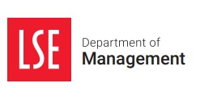
EXECUTIVE GLOBAL MASTER’S IN MANAGEMENT
EGMiM Class Directory – current students

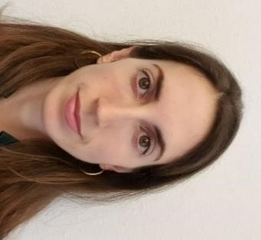
Martina Albers

Nationality: Swiss/Italian
Current Location: Zurich, Switzerland
Current Job Title: Project Manager
Current Company: Albers & Co AG

Bio: I completed my MSc in Mathematics in 2012 at ETH (Zurich, Switzerland). After various internships in Zurich and Singapore, I decided to move to Berlin, where I enjoyed an enriching time at Humboldt University, even getting the opportunity to teach a whole course. In 2015, I came back to Zurich to join our family company in the real estate business. To enter as a mathematician the world of construction and architecture was a fascinating experience - the feeling of creating something as physical and practical as ‘space’, where people can live and work, fills me with joy.
Given that we are a rather small team, my responsibilities lie in various areas such as portfolio management and development. I truly enjoy the variety of my job and the personal connection to my co-workers and our clients.

I hope that the EGMiM will help develop my management skills to further grow in our family business. These are challenging times and it is crucial to find innovative and successful ideas to ensure the company’s future.

_____________________________________________________

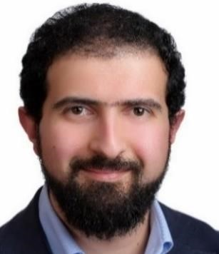
Mohammad Al Dasouqi

Nationality: Jordanian
Current Location: Amman, Jordan
Current Job Title: Deputy CEO
Current Company: Nabil Foods

Bio: I have B.A in Accounting and Certified Managerial Accountant (CMA), enriched with over than 13 years of process manufacturing experience in different industries (Building Materials, Pharma & Processed Food Manufacturing). I like food tasting & travel. Looking ahead, I have plans to be a future CEO or CVO with a more attractive profile for the global market.

_____________________________________________________

Kiara Alves Walters

Nationality: Portuguese
Current Location: London, UK
Current Job Title: Senior Strategy Manager
Current Company: FARFETCH

Bio: I am a Strategy specialist at FARFETCH, focusing on growth strategies and customer-centric transformation programmes in the luxury fashion-tech industry. Prior to my time at FARFETCH, I was a Management Consultant at PwC, where I advised a range of multinational clients on delivering digital strategies, change management programmes, operational reviews and M&A. I hold a bachelor’s degree in Philosophy, Politics and Economics from the University of Warwick. I am excited to use the learnings from the EGMiM programme to advance my leadership capabilities, and become a more all-rounded contributor to my company and to our wider society.

_____________________________________________________

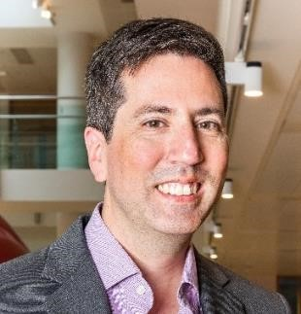
Robert Claire

Nationality: American
Current Location: San Francisco, USA
Current Job Title: Software Engineer
Current Company: Pinterest

Bio: I am a software engineer with over 19 years of experience working with a number of technology and financial companies, primarily in Silicon Valley. I have worked for Pinterest for the past 6 years, with my current focus being in the data engineering function. My main areas of expertise are in data engineering and analysis, cloud computing and distributed systems. I am passionate about working to develop pathways to technology careers for those from nontraditional and diverse backgrounds.

I studied History at the California State Polytechnic University in San Luis Obisbo, and worked briefly in computer animation before I started my career in software engineering. As a student of the some of the technological, economic and geopolitical trends that shape our world, I am thrilled to be participating in the EGMiM program and excited to broaden my perspectives and understanding of the factors that drive opportunity and risk in a global environment. I am particularly looking forward to working alongside and learning from a very international and accomplished cohort. I aspire to use what I have learned from this program to be a more informed advisor and investor in the technology space.

____________________________________________________

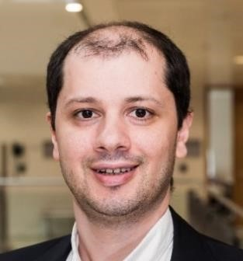
Ashot Davoyan

Nationality: Armenian
Current Location: Yerevan, Armenia
Current Job Title: Lecturer
Current Company: Yerevan State University

Bio: I am an experienced economist with a demonstrated history of leadership in academia, public and private sectors. I am skilled in economics, project development & implementation, strategy and business administration. Nowadays, my research interest mainly focuses on innovations related topics which characterize processes behind economic development and growth in emerging markets and beyond. Throughout my career I have completed academic programs at a number of world’s top universities including Charles University in Prague, Georgetown University in the US and Skolkovo School of Management in Moscow.

____________________________________________________

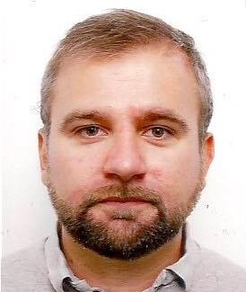
Simone Ferron

Nationality: Italian
Current Location: Lindenberg im Allgäu, Germany Current Job Title: Business Development Manager Current Company: Liebherr Aerospace GmbH.

Bio: A European citizen born in Italy and currently living in Germany, after earning a bachelor’s degree in aerospace engineering, I worked for more than fifteen years analysing satellites, helicopters, and airplanes. I spent the second half of this time leading international teams of engineers, connecting with people from all around the world.

Recently I changed my job to business development manager in the marketing office of my current company, a leading manufacturer in the aerospace industry.

I plan to use this programme to learn more about the way social and economic factors determine the reality we live in and influence myself, to benefit from it for the ultimate purpose of leaving this world a better place to my children.
I started at age fifteen by cleaning offices overnight and I ended up leading people, in circumstances I could have never planned. I made for myself the idea of a career neither as a goal nor as measure of success, rather as a consequence of connecting dots, which someone draws for you, and you draw yourself. This programme is about drawing my dots, and connecting with those of my classmates and LSE.

_____________________________________________________

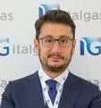
Nunzio Ferrulli

Nationality: Italian
Current Location: Rome, Italy
Current Job Title: Executive Vice President of Institutional and Regulatory Affairs Current Company: Italgas Spa

Bio: Born in 1976, law graduate, I have been Executive Vice President of Institutional and Regulatory Affairs at Italgas S.p.A. since November 2016. I'm a member of the Presidential Committee of ANIGAS and Confindustria Energia.
I've always been involved in Institutional and Public and Regulatory Affairs, in various sectors in different companies like Edison spa, Acea spa, Philip Morris spa e Grandi Stazioni spa. I hope that this course could help to boost my career.

_____________________________________________________

Peter French

Nationality: American
Current Location: Hungary
Current Job Title: Assistant Director of Operations
Current Company: United States Air Force

Bio: I am an officer in the United States Air Force approaching the end of my service commitment and transitioning to a career in the technology space. My intent for the EGMiM program is to gain a business education and expand on the leadership and management skills I have learned throughout my education and military service. I hope to develop an understanding of the global business environment, grow a network with my classmates, and expand my management skills to more effectively lead in today’s constantly evolving age.

I am currently the Assistant Director of Operations and C-17 Evaluator Pilot at the Heavy Airlift Wing. We are a 12-nation strategic collaborative, building capabilities and strengthening alliances between our partner nations by providing a smart, efficient defence program that coordinates airlift between the allies. I received a BSc in Systems Engineering from the US Air Force Academy, and an MSc in Global Technology and Development from Arizona State University, which focused on the impacts that existing and emerging technologies have on human development. I am excited to use the EGMiM program’s focus on the theoretical underpinnings of business and management as I transition to a career in technology, building upon the unique experiences and perspectives gained during my education and military career.

_____________________________________________________

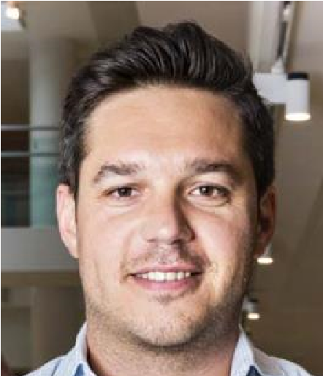
Simon Fritschi

Nationality: Swiss
Current Location: Zurich, Switzerland
Current Job Title: Senior Financial Controller
Current Company: responsAbility Investments AG

Bio: As a trained banking professional, I am well experienced in the financial industry. I am particularly interested in alternative and development investments. The last 10 years, I have worked in controlling functions with a strong focus on financial planning, analysis and advisory. I have worked for Raiffeisen (Swiss retail bank), UBS Asset Management and I am currently employed by responsAbility Investments; one of the forerunners in impact investing. I have studied Business Administration with a focus on Banking & Finance at the Zurich University of Applied Science in Switzerland and I am a CFA charterholder.

My ambition is either to move into a CFO role or launch a consultancy to supporting companies to access the full potential of the corporate finance function. I strongly believe that the corporate finance function can bring the greatest value to companies when it has access to the most relevant data and is fully integrated into strategic decision-making. I expect the program to challenge my current knowledge and experience through the curriculum and the combined experience of my international cohort. I hope to broaden my professional focus and have a memorable time.

____________________________________________________

Adam Griffin

Nationality: South African / Australian
Current Location: Cape Town, South Africa
Current Job Title: Chief Operations Officer
Current Company: ELDO Energy

Bio: I consider myself an experienced leader with a proven track record of success in the corporate and SME sectors, having had a successful exit in 2018 of a consumer electronics business in Australia. An entrepreneur by heart, I am currently the COO of ELDO Energy in South Africa. ELDO is a utility-tech company that provides leading solutions and services to utilities, network operators, service providers and end-user consumers. Our solutions enable accelerated digitisation of electricity, water and gas distribution systems, driving our day-to-day lives towards a more efficient, connect, transparent and transactional utility future.

____________________________________________________

Nora Harless

Nationality: American
Current Location: Hargeisa, Somaliland (Somalia)
Current Job Title: CFO
Current Company: Abaarso Network

Bio: I graduated with high honors from New York University (NYU), where I studied Spanish, working in disaster relief and conducting research in Central and South America. After graduation, I moved to Somaliland, an autonomous region in northwest Somalia, to work at an American-style secondary school. I have been working for the same organization since, leaving briefly in 2017 to complete a post-graduate fellowship with Princeton University working in non-profit school development in Bolivia. I returned to Somaliland in 2018 to manage operations and finance as a founding team member at Barwaaqo University, Abaarso’s subsidiary sister school. In 2020, I joined the Abaarso Network staff as CFO, managing finances for the three school systems in the organization, overseeing risk management, partner investments and financial reporting.

____________________________________________________

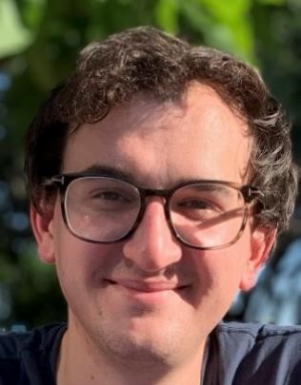
Ethan Hendrickson

Nationality: American
Current Location: Houston, USA
Current Job Title: Sr. Consultant, Rewards
Current Company: Aon

Bio: I attended the University of Texas at Austin graduating with degrees in International Relations and Arabic, with a focus in Middle Eastern studies. Shortly after graduation, I began working at Aon in SAP and Workday implementations before moving into the Compensation/Rewards consulting practice where I am today. I work closely within the energy and tech industries (both large, established tech firms and start-ups).

I am hoping to use this program to build a strong foundation of finance and management knowledge and then pivot into one of Aon’s other rewards markets in APAC or EMEA.

_____________________________________________________

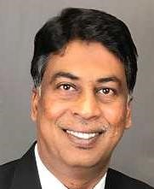
John Jennyson

Nationality: India
Current Location: Atlanta, USA
Current Job Title: President, People and Organisation
Current Company: Wood Plc

Bio: I am a citizen of India and live in Atlanta, GA (permanent resident of USA). My academic background consists of a master’s degree in commerce (1991) and a bachelor’s degree in commerce (1989) from Osmania University, Hyderabad, India. Presently, I serve as President, People and Organisation (HR) for Consulting division of Wood plc (www.woodplc.com). Wood’s Consulting division employs ~11,000 people in about 28 countries with revenue of $2 bn. Wood employs 45,000 employees in 60+ countries with revenue of $10bn and provides performance-driven solutions throughout the asset life cycle, from concept to decommissioning across a broad range of industrial markets, including the upstream, midstream and downstream oil & gas, power & process, environment and infrastructure, clean energy, mining, nuclear, and general industrial sectors.

EGMiM is the program I identified as part of my continued professional development in preparing for an enterprise lead role. The fact that LSE is an internationally recognized brand leader, renowned for its academic excellence is of great value to me. I believe EGMiM will provide me the tools and cutting-edge critical thinking skills to enhance strategic thinking at a Global level and provide contemporary evidence-based management skills required of a leader for an international business.

_____________________________________________________

Rachel Kaplan

Nationality: USA
Current Location: London, UK
Current Job Title: Senior Commercial Manager Current Company: Tangle Teezer Ltd.

Bio: I graduated from Northwestern University in Chicago with a dual degree in Economics and English Literature – gathering a multi-faceted understanding of why humans make the choices they do. From there, I’ve built a career in consumer product marketing in the beauty and technology spaces at companies such as L’Oreal and Dyson – where I spent 6 years in various roles from brand to sales to product development. Roughly 2 years ago, I made the move from the US to Southwest England for a secondment at Dyson’s HQ in Malmesbury, UK. However, in August I’ll be relocating to London as I’ve just taken on a new role at Tangle Teezer, a smaller British beauty brand. There, I'll be developing a new product strategy team from the ground up. I hope the LSE program will arm me with the broader skillset needed to progress as a leader within my industry – in topics such as organizational behaviour, entrepreneurship and finance. I also look forward to the global network we can build within our EGMiM cohort.

___________________________________________________

Ruslan Karimov

Nationality: Uzbekistan
Current Location: Tashkent, Uzbekistan
Current Job Title: Director, Treasury Department
Current Company: JSCB "InFinBank"

Bio: I have +10 years of experience in commercial banking. My knowledge spans to the areas in risk management, treasury, international borrowings, corporate governance, compliance, and accounting. I received my bachelor’s degree in Economics at Tashkent State University of Economics and my master’s degree in Quantitative Finance at Vienna University of Business and Economics.

The next stage of my career would be the deputy CEO with focus on the retail business line. That position requires management of the team up to 100 people and requires the strategy shaping that business. With my degree in global management from LSE, I would be better prepared for that role in terms of managing people and constructing the business strategy in highly competitive environment.

_____________________________________________________

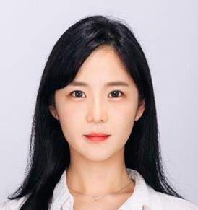
Minsun Kim

Nationality: South Korea
Current Location: Seoul, South Korea
Current Job Title: Director of New Business Planning & Strategy Division Current Company: Panstar Group

Bio: I am currently working at a family-owned shipping company that connects China, Japan and Korea via the East Sea, designing and implementing short and long-term business plans. I occasionally manage the entire process of ship trading as well as acquisitions of Chinese and Japanese corporations. Recently, I have been developing a new service that innovates the logistics system between Korea, China, and Japan using data analysis. Prior to joining this company, I worked as a private banker at Wooribank, a commercial bank in Korea. This experience helped me to develop a quantitative way of thinking and to network with financial circles. I completed my undergraduate degree in Business Administration and History at Sogang University in Seoul. While I was in school, I rolled out a mobile-based tour platform and operated it for a year and a half, raising funds from both the Korean government and Sogang University.

I want to expand my business field to the world outside of Korea through LSE’s in-depth academic approach and networking with class cohorts from around the globe. Utilizing the resources of LSE, I would like to receive assistance in seeking independent business opportunities not limited to my current job, and increasing the chances of the business’ success.

_____________________________________________________

Tatiana Kononovich

Nationality: Russian
Current Location: London, UK
Current Job Title: Head of Commercial Operations
Current Company: Forextime UK Limited

Bio: I studied international economics at Russian Foreign Trade Academy and graduated in 2015. I started working whilst was studying in the university in 2013. I entered 2-year internship programme at Bosch in Automotive Equipment Division. Later after graduation I worked for 1 year in IKEA Centres as Marketing Coordinator which was very exciting and promised further career prospects and growth within the organisation in Marketing Division. However, I found a job in Cyprus in the financial company called FXTM and moved to Cyprus in October 2016. I had a few role changes within the organisation:

2016 - Sales Administrator
- - Senior Sales Administrator
- (January) - Head of Sales Administration 2019 (April) - Head of Commercial Operations

My current role covers a very broad area of responsibility: development of new markets for the company, control of commercial expenses and budget, leading strategic Partner in the Middle East and development of the region, control and coordination of marketing and sales projects.

I believe this programme will boost my knowledge and professional experience. I hope to progress within the current company I work for and hold a senior management position after graduation.

_____________________________________________________

Musica Lorence-Evans

Nationality: American
Current Location: London, UK
Current Job Title: Consultant
Current Company: Self Employed

Bio: I have recently completed my undergraduate degree in business from the University of London, previous to my educational pursuit I was a Retail Director in NYC for several years. I will use the experience and teachings of the LSE EGMiM programme to expand my international career horizons. In addition, I will use the programme to expand my professional network.

_____________________________________________________

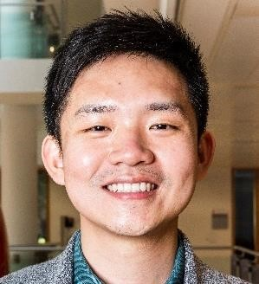
Kai Lu

Nationality: Singaporean
Current Location: Chongqing, China
Current Job Title: Manager
Current Company: CapitaLand Limited

Bio: My first name is Kai, a married 33-year-old Singaporean with a supportive wife and two lovely daughters. After graduating in 2011 with a Master’s in Chemical Engineering (Honours Class 1) from the University of Birmingham, United Kingdom, my professional career took me from being a resident in Singapore to living in the perspiration inspiring Oman, then moving on to experience the pre-Modi era of India, before settling in mountainous Chongqing, one of the four municipality cities in China, for the past five years.

I’m currently with CapitaLand Limit, one of Asia’s largest real estate developers, working on a USD 3.5 billion integrated development that is Raffles City Chongqing. It is the single largest investment in China made by a Singapore company. At present I’m heading its new business division, focusing on the experiential, media and tourism aspects of the development.

Being able to attend the EGMiM programme at LSE will fulfil one of my life-long dreams I had since I was a student, which is to be an apprentice at one of the world’s top business schools. Unquestionably, with the LSE brand, knowledge and network gained, I will be better equipped to achieve my career aspirations and be a role model for my two daughters to emulate when they come of age.

_____________________________________________________

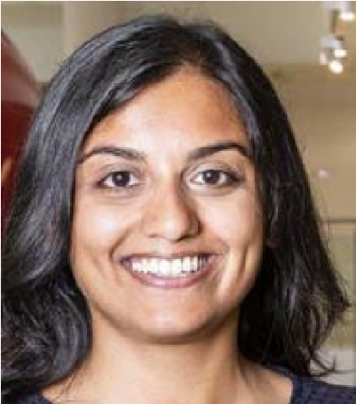
Lakshmi Maithel

Nationality: United States of America
Current Location: Boston, MA, USA
Current Job Title: Business Development Manager
Current Company: Genedata

Bio: I have a Bachelor's in Economics from UC Berkeley and Master's in Biotechnology from the University of Pennsylvania. My work experience includes three years on the solution sales team at Elsevier followed by two years as Program Director for GenomeAsia 100K where I added partners to the non-profit consortium in order to generate more genomic data on Asian populations. I also recently worked with Repositive, a startup based Cambridge, UK committed to increasing the discoverability of biological data to enable medical research. I am currently Business Development Manager at Genedata for the Profiler platform which enables a precision medicine approach to clinical trials. My goal in the LSE EGMiM programme is to develop the management skills necessary to build a sales team for Profiler’s next stage of growth.

Outside of work I volunteer with non-profit organizations including India Biotech Leaders of Tomorrow and Asha for Education - a charity supporting education initiatives in India by raising funds for underprivileged schools.

_____________________________________________________

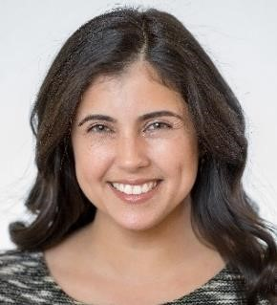
Yarissa Matos-Soto

Nationality: American
Current Location: Tampa, USA
Current Job Title: Management Consultant
Current Company: Deloitte Consulting, LLP

Bio: I currently work as a management consultant within the Operations Transformation practice at Deloitte specializing in areas of improving global health outcomes and designing digital transformation strategies. In my role, I advise CEOs, COOs and Government leaders of health-focused organisations in, Europe and North America. Prior to consulting, I worked as a scientist in tracking infectious disease outbreaks and evaluating the social determinants of health. I obtained my Bachelor’s degree in Biochemistry from Rollins College.

I am interested in international politics and relationships between countries. I read widely about cybersecurity, emerging technology and global health. I hope to work in a role with an international scope that will bring innovation to health organizations and how we view health through public-private collaborations.

The EGMIM program provides the ability to assess the social, political, and economic interplay on business interactions within our current complex world. I hope to break away from the conventional, dichotomous way of thinking about business models - those that are profit-seeking and those that are not. Time has come for a new way of doing business that is sustainable and contributes to societal good.

_____________________________________________________

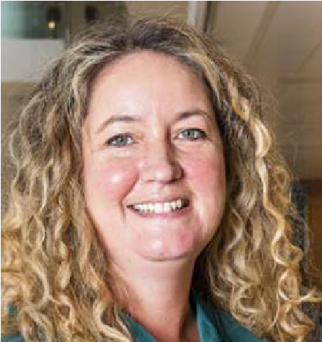
Rebecca McLerie

Nationality: British
Current Location: Dubai, United Arab Emirates
Current Job Title: Partner
Current Company: Clyde & Co LLP

Bio: Originally from England, I have been living in Dubai for over 11 years. I am a partner in an international law firm, Clyde & Co LLP which is headquartered in the UK, and I co-head the MEA employment law practice. I primarily advise companies on their HR issues across the Middle East, which frequently requires swift action to manage a crisis or to protect a company's reputation. This can range from advising clients on ways to protect their confidential information, advising on bullying and harassment complaints, and appearing in the Dubai International Financial court on behalf of a client in a dispute for non-payment of bonus or defending a decision to dismiss an employee for gross misconduct. A professional highlight in the past year has been drafting the new employment law for the Dubai International Financial Centre (coming into force on 28 August 2019).

My first degree was a BA (Hons) in Law and Business and having worked as a lawyer for almost 20 years I am now coming back to the study of business through the EGMiM at a time in my career when my interest is moving from "doing" the law to the "business" of law. I am particularly looking forward to learning about some of the theories in management and leadership.

_____________________________________________________

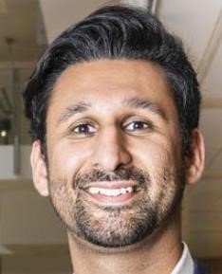
Aun Merchant

Nationality: American
Current Location: Orlando, FL USA
Current Job Title: Senior Manager
Current Company: PwC

Bio: I currently work as a management consultant within the financial services advisory practice at PwC, specializing in areas of treasury and risk management. In my role, I advise CFOs and CROs of global financial institutions mainly in Asia, Europe and North America on a variety of topics some of which include, enterprise wide data strategy, funding and liquidity strategies to achieve an optimal balance sheet structure and financial performance, Target Operating Model design, Regulatory compliance and enterprise architecture. Prior to consulting, I worked as an investment banking where I worked on a variety of sell side and buy side engagements across the aviation, healthcare, and consumer sectors. I obtained my bachelor’s degree in Business majoring in Finance from the University of Florida.

With the EGMiM program, I hope to complement my treasury and risk background as well as my analytical skills with an in-depth understanding of other management functions, along with the socio-economic forces shaping the global economy to further develop as a global professional and leader.
_____________________________________________________

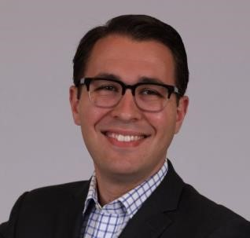
Daniel Mintz

Nationality: American
Current Location: Washington DC, USA
Current Job Title: Associate Director
Current Company: The Glover Park Group

Bio: I am currently an Associate Director in the strategic communications division at The Glover Park Group, a Washington D.C.-based consulting firm. I primarily work with financial services clients, focusing on public affairs, reputational risk, and crisis communications issues. Prior to my current role, I worked in the Office of U.S. Senator Jeff Flake where I served as Speechwriter and Communications Advisor. Before joining Senator Flake’s office, I served as Director of Communications and Marketing at Delve, a start-up competitive intelligence firm. Previously, I also worked as a political research consultant preparing opposition research and policy analysis for U.S. political campaigns. I attended The George Washington University in Washington D.C. where I received a B.A. in Political Science with a concentration in Public Policy.

I plan to use the programme to provide me with a better working knowledge of the business fundamentals necessary to make a successful transition from a career in government and politics to corporate strategy and consulting.

_____________________________________________________

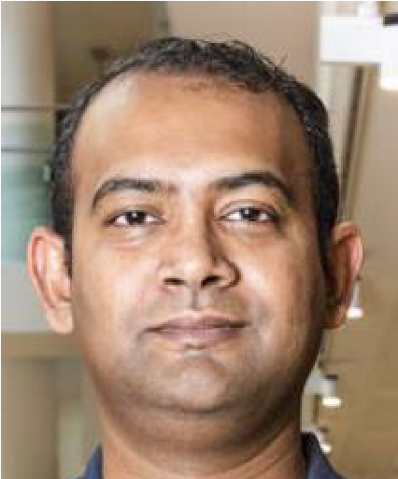
Prasanna Mohan

Nationality: Indian
Current Location: Abu dhabi, United Arab Emirates
Current Job Title: Regional Director - Middle East
Current Company: Sulzer

Bio: I am a Mechanical Engineering a childhood dream that I went ahead to pursue at the midst of a software wave that was sweeping India as it was my strong belief that manufacturing forms the fundamental backbone of any economy.
I am currently the Regional Sales Director for Sulzer Pumps based out in Abu Dhabi, UAE and a rich exposure to international market having worked in Europe and Middle East for the past 10-12 years.

The experience gained in managing an organisation is considerable and the personal growth achieved reflected this effort. At the same time, I also sensed a gap and need to gain better understanding to translate my thoughts into structured ideas and streamlined processes that will help in achieving desired results. I realised the need for right kind of education to help me strike the right balance and utilise my managerial experience to its fullest potential. I strongly felt a master’s in management with a focus on current global economics would help accelerate my growth and shape me into a management professional with virtually unlimited potential.

_____________________________________________________

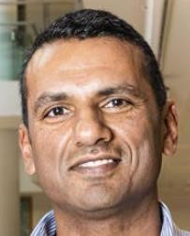
Yorshan Naidoo

Nationality: New Zealand, South African
Current Location: Floreal, Mauritius
Current Job Title: Pilot
Current Company: Air Mauritius

Bio: I am an airline pilot presently flying for Air Mauritius on the Airbus A330 aircraft. I have just over 21 years’ experience as a pilot. I fly the long and medium range routes. Previous to this, I flew for South African Airways on the Airbus A340/330. Prior to starting my airline career, I was a pilot in the military. I served in both the South African and Royal New Zealand Air Forces. I learnt to fly in the South African Air Force. I later joined the Royal New Zealand Air Force and then returned to South Africa to finish my military career. I flew in the maritime and transport lines on many different types of aircraft in a variety of different roles. I was also an instructor pilot and trained ab-intio students and was then appointed to head up the training section of a transport squadron as Training Co-ordinator. I represented the Airline Pilots Association (ALPA) of South Africa in the security portfolio. Before I joined the military, I attended the University of Hawaii on a tennis scholarship. I am also presently developing 2 different businesses.

I intend to use the skills and knowledge of the EGMiM programme to grow in the business/ management side of the aviation sector globally and enhance my development in entrepreneurial field.

_____________________________________________________

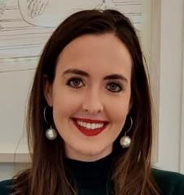
Colleen Osborne

Nationality: American
Current Location: London, UK
Current Job Title: Vice President, Corporate Banking
Current Company: RBC Capital Markets

Bio: I am currently a Vice President in Corporate Banking at Royal Bank of Canada, North America’s 5th largest bank and a premier, full-service investment bank with a strong US presence and significant momentum across four continents, particularly Europe. I have been with RBC in Corporate Banking for six years – the first three I was New York-based and then relocated to our London team in July 2018. Prior to RBC I worked for BNP Paribas in New York, where I was a part of a rotational graduate program through their Corporate Coverage division, for three years. I received my undergraduate degree from Marquette University in Milwaukee, Wisconsin, where I majored in Finance and Information Technology. At Marquette I was a member of the Applied Investment Management program, which allows Finance majors to get handson experience through active management of university endowment funds across both equity and fixed income portfolios.

I believe the format of the EGMiM program will allow me to translate learnings and strategic thinking into my role nearly real-time, and eventually provide the skills and confidence required to lead in a management capacity. I look forward to growing my professional network with individuals outside of banking.

__________________________________________________

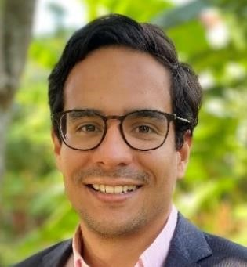
Juan Paredes

Nationality: Colombia
Current Location: Nairobi, Kenya
Current Job Title: Research Scientist
Current Company: icipe

Bio: I am a research scientist and project leader with 10 years of experience in insects-symbionts research applied to sustainable agriculture in sub-Saharan Africa and Latin America. At icipe, I am currently investigating new microbe-based products to improve human, animal, plant and environmental health. I have a Ph.D in Entomology and Genomics, and fluent in English, French and Spanish.

After EGMiM I would like to change my career path towards social entrepreneurship venture.

____________________________________________________

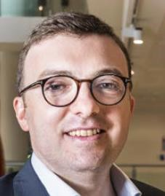
Gregory Perret

Nationality: French
Current Location: Geneva, Switzerland
Current Job Title: Analyst
Current Company: Crescendo Capital

Bio: I graduated from Ecole Hôtelière de Lausanne in 2003 with a BSc in International Hospitality Management. I then started my career as a cost controller for Sheraton and then as a Food and Beverage Manager for Sofitel for three years in Philadelphia. My role consisted in managing the overall Food and Beverage operations for the hotel as well as implementing cost control measures. I then quit to pursue an MSc in Finance from EDHEC Business School in Nice. Upon graduation, Crescendo Capital, S.A., a Geneva-based multi family office hired me as an Analyst. Since then, I have been working alongside the team and the partners to develop the company’s activities and to evolve it from an entrepreneurial venture to becoming a global player. My main role within Crescendo consists in the funds’ selection, analysis and monitoring as well as portfolio management.

Since this year, I am also engaged within an association financing and developing humanitarian projects helping disadvantaged populations and children living in developing countries especially in Vietnam.

The EGMIM program will allow me to equip myself with the necessary skills, tools and knowledge to embrace the changes that are affecting us in order to orientate my career in the coming years.

_____________________________________________________

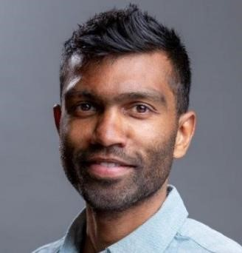
Sreeram Ramagopalan

Nationality: British
Current Location: London, England
Current Job Title: Global Head Real World Evidence
Current Company: Roche

Bio: I am a trained epidemiologist (having completed a masters and PhD in epidemiology). I was a research academic for a while before joining the pharmaceutical industry. I started off a consultancy before moving through a number of different pharmaceutical companies. I am currently at Roche, based in Basel, Switzerland. I am in very technical functions in pharma and plan to use the course to broaden my skill set to take on more strategic positions.

____________________________________________________

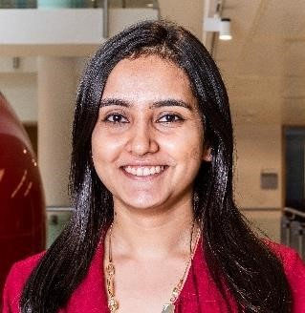
Disha Selarka

Nationality: Indian
Current Location: Mumbai, India
Current Job Title: Founder and Director
Current Company: Giftract

Bio: I graduated with a bachelor’s in information technology. Fresh out of school, I started my own website called www.giftract.com which is about creating Gifts that Interact in the form of personalised APPs and games. I have also undergone leadership training by my mentor on Chanakya’s Arthashastra model.

The reason I have chosen the EGMiM is because it allows me to go to LSE, get a masters to broaden my management skill set and keep my business without having to choose between the two. (a choice I had to make 2 years ago when I was accepted to another program here) My goal is to improve the performance of my business and become a better entrepreneur. My long term goal is to further grow my father’s company – Acma Computers Ltd. along with my brand, Giftract side by side.
_____________________________________________________

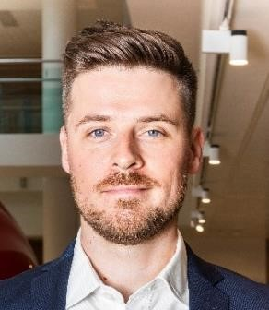
Jordan Shaw-Young

Nationality: Canadian
Current Location: Toronto, Canada
Current Job Title: Director of Strategic Accounts
Current Company: Tanium

Bio: I completed my MA Philosophy in 2008, and upon discovering that “philosopher” isn’t an easy career to pursue in the 21st century, have been working in the cybersecurity industry ever since.

I’m very much looking forward to working on an interesting dissertation at the conclusion of the programme, ideally focusing on the theory of the firm with some practical input from my background in cybersecurity and political theory. I’ll also be looking forward to absorbing as much as possible from this undoubtedly talented EGMiM cohort.

_____________________________________________________

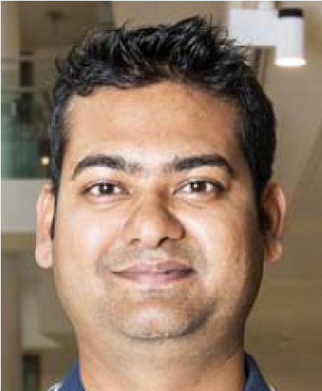
Ashutosh Shukla

Nationality: Indian
Current Location: Cork, Ireland
Current Job Title: Associate Director - Packaging Engineering & Operations Current Company: Gilead Sciences

Bio: I hold Bachelor of Engineering in Biotechnology and master’s degree in Packaging Technology. Over almost a decade long career, I have worked across different business verticals ranging from R&D, Manufacturing site to Regional/CMO supply chain in corporate setting. Exposure of working in both emerging and developed markets across multiple geographies is key contributor in my skills, career and personality development. Majority of my experience has been in Pharmaceutical and FMCG Supply Chains, with accomplishments like delivering complex-high impact projects with over 50+ Contract Manufacturing partners across globe, managing multimillion pounds of Capex/Opex budget, developing high performance team culture, simplifying supply chain operations etc.

From the EGMiM programme at LSE, I am looking forward to gaining rich understanding of theoretical concepts and its applications in areas like Financial Management, Marketing, Strategy, M&A, Organizational Behaviour and Change Management through the lens of changing geopolitical and economic dynamics. I also believe that formal management education at one of the best schools in the World, which focuses on the “Causes of Things”, will be a great learning experience. I know the skills I will develop over this course will help me in achieving my long-term professional goal of leading a global multi-billion-pound organization.
_____________________________________________________

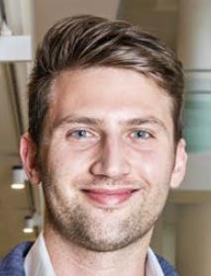
Aleksander Simoski

Nationality: German
Current Location: Dusseldorf, Germany
Current Job Title: Manager, Management Consulting
Current Company: PwC

Bio: I hold a BSc in business administration and an MSc in Finance from the Business and Information Technology School in Germany. During my studies, I had also stayed in London and Paris for my terms abroad. I went on to start my career at PwC in Germany within the Capital Markets and Accounting Advisory Services unit. The assignments I have worked on include financial accounting transformations as well as M&A and capital markets driven transactions. Whilst at PwC, I have worked on multiple international assignments with listed companies in more than 20 countries on four different continents. I am currently based in the Dusseldorf office but have also worked in the Shanghai office in China. Recently I transitioned to Management Consulting where my focus of work is rather on organizational and process related challenges within the finance function (Finance, Accounting, Controlling, Tax) and its impact on a business.

After my MSc I continued my education with the CFA charter as to round off my finance and accounting background. With the LSE EGMiM programme, I want to discover about management and leadership in an international context. I want to understand the rationales behind the decision making carried out at organisations. I look forward to collaborating with a diversely talented cohort and learn to lead with vision and purpose.

_____________________________________________________

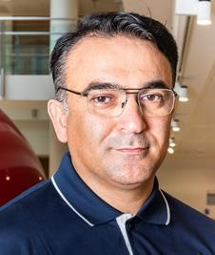
Vugar Suleymanov

Nationality: Azerbaijani
Current Location: Baku, Azerbaijan
Current Job Title: CEO
Current Company: Qazax Cement Plant LLC

Bio: In 1991-1996 graduated from the Law faculty of Baku State University. In 2008 graduated LLM Corporate Law from the Nottingham Trent University, UK. In 2009 attained Graduate Diploma in Law from Nottingham Law School. In 2010 attained legal professional course of Corporate Pathway from the Nottingham Law School. In 2011-2015 held a number of senior management positions at Ateshgah insurance Company. Starting from 2015 had proceeded to work in executive positions at Akkord Industrial Construction Investment Corporation. Since 2018 is the Member of Supervisory Board in Akkord ICIC. From 2018 until now is CEO of Gazakh Cement Plant LLC.

I would like to implement the knowledge which I will get from the program to apply in my current business in cement plant and also apply these skill in my daily management routine. I need to develop my knowledge in strategic management up to new level.

_____________________________________________________

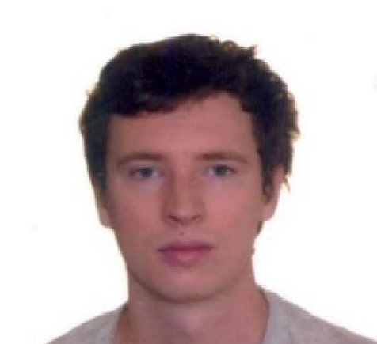
John Szlazak

Nationality: Canadian
Current Location: Ottawa, Canada
Current Job Title: Commercial Manager
Current Company: Solon

Bio: I undertook study in human geography and cinema in undergrad. I had a longstanding interest in film and intended to go into the field but took on a second major in case that wouldn’t remain the case as I matured and neared graduation. I closed the door on film, and only with time did a nascent interest in geography and geopolitics begin to come forward. In the meantime, I took on resource work in western Canada to save up for world travel, working in forestry in the spring and summer and on a subarctic oil rig throughout the winter, until reaching the financial goal I had set for myself to embark on world travel. I flew to Cape Town, purchased a bicycle and cycling north, across the continent over a year, then into India once Africa was complete. I longed to return to Africa however, and started a search for some living, working capacity that might bring me back there full time. I secured a role with Canadian venture capitalists in West Africa, where I most recently helped launch the region’s first ride hailing platform.

Through the EGMiM program, I hope to formalize then broad business exposure I have enjoyed over the past few years. I anticipate that the theoretical backdrop will encourage me to look inward, to develop my own ideas in business.

_____________________________________________________

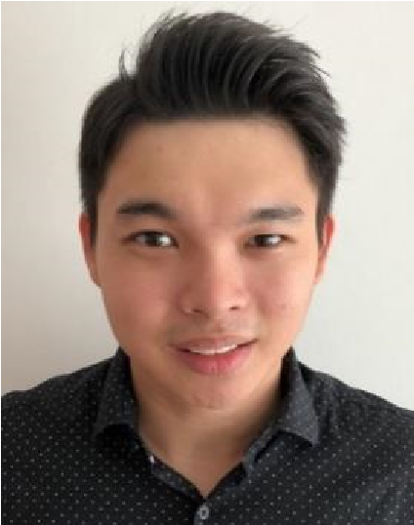
Andrew Tong

Nationality: Singaporean
Current Location: Singapore
Current Job Title: External Consultant
Current Company: MIT

Bio: It is a privilege to be part of the world-renowned EGMiM programme that is brilliantly structured to develop students’ social science approaches and capabilities to solve sophisticated problems across this dynamic business environment. I am exuberant to be learning from distinguished professors, industry leaders, and a highly diverse class that engages intellectually to derive better strategic decisions.

My academic background is in management, with a specialization in advanced corporate finance. One of my scholarly interest is in applying discrete choice analysis to management strategies.

Professionally, I manage the business aspects of projects in both MIT and SMART (MIT's overseas research centre in Singapore). I work in an interdisciplinary laboratory which focuses research on Future Urban Mobility (E.g., Autonomous Vehicles, Cities of Tomorrow, Smart Solutions, and many others).

I believe the EGMiM experience allows me to craft my career that reflect my aspirations. I intend to lead projects using management science that benefit both my collaborators and institution. Ultimately, I intend to add value to make this world a better place - one workplace at a time, starting from my own.

____________________________________________________

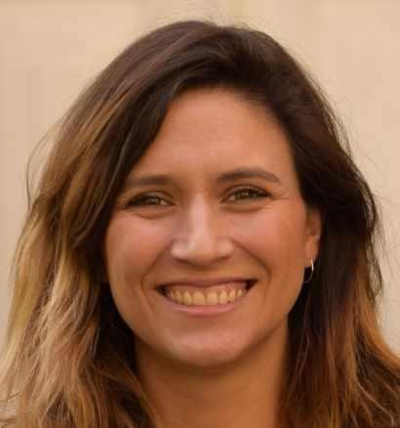
Catalina Troncoso Rojas

Nationality: Chilean
Current Location: Providencia, Santiago, Chile
Current Job Title: Head of Finance
Current Company: wherEX

Bio: I'm an industrial engineer from University of Chile, graduated with the highest honours in 2010. My thesis was about Pricing Optimization, and my first job was as Administration & Projects Leader, I have worked in different sectors, even in the public sector in the Ministry of Education of Chile, but always been linked with finances and analytics. Now, I'm the Head of Finance of wherEX, a Chilean startup, leading a team of 17 people and being part of the senior leadership team.

wherEX is in international expansion, we have just finished our first Serie A capital raise and opened an office in Mexico, there is so much to come and I want to be prepared for it, to lead my departments (Finance, Administrations and Planning & Analytics) and afterward, probably a couple of years later, to lead this or another company ready to be global, sustainable and part of the change to be a better world for all and everyone.

____________________________________________________

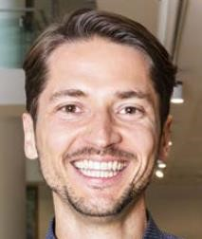
Thomas Wycislo

Nationality: German
Current Location: Frankfurt, Germany
Current Job Title: Team Head Asset Management Retail North & Central Europe Current Company: Allianz Real Estate

Bio: Following on from my degree in architecture, I today head up the retail Asset Management team at Allianz Real Estate in Northern and Central Europe. My personal evolution from studying architecture towards working in the financial sector of real estate was possible after a traineeship at a financial advisory firm in 2008 followed by several years of transaction experience. Subsequently, I transitioned further into Asset Management when offered the chance to join the Londonbased team at TIAA-Cref Asset Management. As much as I enjoyed living in London (including the rich variety of cultures and people), after a few years I moved back to my native Germany to join my current employer.

I look forward to broadening my management skills at LSE, meeting the EGMIM community and benefitting from the different experiences of my fellow students.
_____________________________________________________

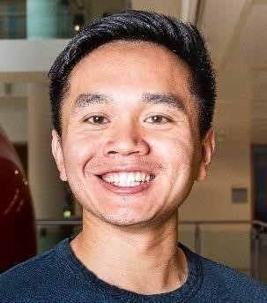
Haotian Xu

Nationality: American
Current Location: Washington DC, USA
Current Job Title: Associate
Current Company: Booz Allen Hamilton

Bio: I graduated from Williams College with Bachelor’s in History and Economics. Since then, I’ve obtained industry certifications in Design, Project Management, and Data Analytics. I have worked for Booz Allen Hamilton for the past six years. I am passionate about movies, traveling, finding good food, and spending time with friends. I run a movie theatre review site, and sit on the board of a non-profit in Kenya benefitting widows. I plan to gain understanding of business strategy and foundational knowledge to accelerate my career growth, as well as broadening my global network to eventually transition to the entertainment industry as an entrepreneur.
____________________________________________________

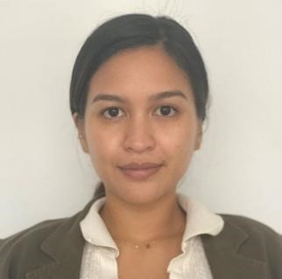
Audria Zahiruddin

Nationality: Indonesian
Current Location: Jakarta, Indonesia
Current Job Title: Owner and CEO
Current Company: Mood Wellness Studio and Kitchen

Bio: I studied abroad since I was sixteen taking the IB Diploma in EFIA Torbay in the UK. After that, I took my bachelor’s degree in Hotel and Tourism Management at New York University in the USA. In the midst of taking my BSc, I went to NYU Paris Campus to learn the language and the culture for six months. During my time in NYU, I did a lot of internships in my field. My internships were with Taj Hotels - The Americas, Ritz Carlton Central Park, and Expedia. Immediately after graduating, I worked as an Account Manager at Le Meridien Jimbaran & The Dharmawangsa Jakarta straight after. After working for almost three years, I decided to take a gap year taking Culinary Diploma at Le Cordon Bleu Tokyo.

I opened with first business after that focusing on healthy kitchen and wellness centre in my neighbourhood called Mood Wellness Studio and Kitchen. The business also focuses on Yoga and Meditation, offering daily classes, workshops, and merchandises that correlates with the core of the business. I am also a certified RYT 200 Yoga Teacher. I am a very active person and likes to dance, box, cycle, and swim. I am hoping the program will help me find ways to develop new skills needed to grow my business.
____________________________________________________

Monika Zec

Nationality: Croatian
Current Location: Zagreb, Croatia
Current Job Title: Head of Investment Banking
Current Company: InterCapital Securities Ltd

Bio: I earned BSc degree in International Economics at Bocconi University. I am currently Head of Investment Banking in InterCapital Securities Ltd, the largest private financial institution in SEE region. I have more than 10 years of experience in corporate finance advisory, especially M&A and capital market transactions. Outside of work, my interests and hobbies include volunteering with children, hiking and travelling. I decided to apply for this programme as I want to further develop my managerial and leadership skill and progress within my current company.

