ORCID integration FAQs
Contents
Connecting Pure: 2
I cannot log into Pure, what do I do? 2
I cannot see the Personal workspace in Pure, how do I fix it? 2
My Pure record already has an ORCID, do I need to do anything? 2
How long will it take for new research outputs added to Pure to feed into my ORCID record? 3
Do I have to wait a month for updates to appear on my ORCID record? 3
Managing your ORCID Record: 3
Who curates ORCID records? 3
How do I change the visibility of content on my ORCID profile? 3
How do I manage multiple versions of the same work? 4
Trusted parties 5
What is a trusted organisation? 5
What is a trusted individual? 5
How do I add/remove access to a trusted organisation? 5
How do I add/remove access to a trusted individual? 5

Connecting Pure:

I cannot log into Pure, what do I do?
If when entering your LSE username and password, you are unable to log in to Pure, please contact the Research and Innovation division at research.systems@lse.ac.uk for assistance.

I cannot see the Personal workspace in Pure, how do I fix it?
If after logging into Pure, you are unable to see the “Personal” menu/workspace, the likely cause is that you have no publications currently associated with your account. You can however enable the menu via your user profile settings. To do this, click on your username in the top menu bar. Under the profile menu, tick the box “Always show the personal workspace”, followed by clicking on the save button.
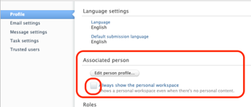
Note: After enabling, you’ll need to log out to refresh the workspace. Once logged in again, the menu options should appear. If the above does not work, please contact the Research and Innovation division at research.systems@lse.ac.uk.

My Pure record already has an ORCID, do I need to do anything?
In some cases, the School has taken the liberty to enter ORCID iDs for staff. However, you may still need to authorise LSE as a ‘Trusted Party’ to enable us to interact with your record. You can tell whether further action is required based on the text directly below the ID, as it will state ‘Authorise export of content to ORCID’.
- Image of a record with no ORCID.
- Image of a record with an ORCID entered but not authorised.
3. Image of a record with an ORCID entered and authorised.

How long will it take for new research outputs added to Pure to feed into my ORCID record?
New outputs will be added as part of a monthly update. This will take place on the 1st of each month, however, please note that for research outputs to be passed through the feed the status must be Epub ahead of print or Published, be marked as public in Pure and have been validated by the Library. Queries relating to this process can be sent to lseresearchonline@lse.ac.uk.

Do I have to wait a month for updates to appear on my ORCID record?
No. As a user of Pure you have the ability to initiate an independent upload that is limited to only your research outputs. To achieve this, simply log into Pure via cris.lse.ac.uk. Click on Edit profile and select the option ‘Export’ which is located to the right of your ORCID iD. Following this, you can simply close the record, there is no need to save. On later review, your profile will show a ‘last exported’ date to indicate when content was last exported.

Managing your ORCID Record:

Who curates ORCID records?
Ultimately, it is you, the researcher/academic, who manages your ORCID record. This means that you have full control over what content is displayed on your profile, including employment, education and qualifications, awards and prizes, funding and publications.
As a user, you can, however, grant permission to other ORCID members, either individual users or organisations, to view and/or add information to your record. The transfer of employment details from Pure to ORCID is limited to high level classifications and you may wish to edit ORCID manually to include more detailed employment information.

How do I change the visibility of content on my ORCID profile?
ORCID provides two means by which users can change the visibility of content on their profile. The first is an individual toggle on each content type, which allow you to alter the setting between; everyone, trusted parties, and only me.
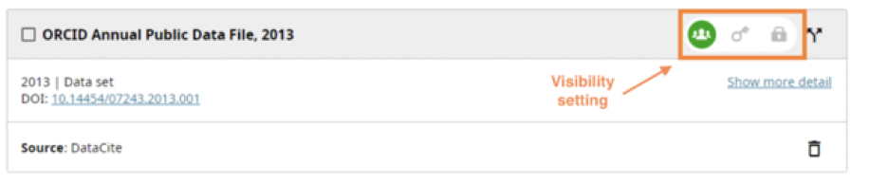
Note: For publications, you can alter the visibility in bulk via the actions menu.

The alternative option is to change the global visibility setting in account settings. This can be accessed via the dropdown menu on your profile icon/name and by selecting “Account settings”. Under the “Defaults” section, expand the visibility accordion and select the preferred option.
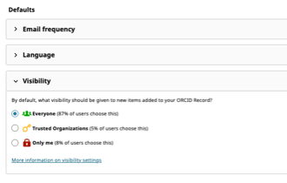
Note: The change only applies to new items. Existing content must be toggled manually from your profile page.

How do I manage multiple versions of the same work?
The same work can be added to your ORCID record from different sources and it can make your record more authoritative. Typically, when works have common identifiers (such as a DOI, ISBN, etc.), they are automatically grouped, as they represent the same item. However, many of these identifiers are case-sensitive, and so, much like a record without an identifier, they will not be grouped.
To manage these multiple versions, you can make use of ORCID’s action menu, located at the top of the works accordion to combine works. To do this, simply, highlight the applicable works by ticking the tick box in the top left corner of the work card, followed by selecting the “Combine works” option from the actions menu. After a work has been combined, you’ll notice that the work will have a new “preferred source section.
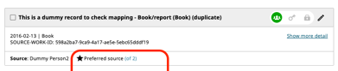
Clicking on the blue text will expand the card to reveal the additional versions. From here you can change the preferred source, in other words, the displayed version.

Trusted parties

What is a trusted organisation?
A trusted organisation has access to your ORCID record with the ability to create and/or update content.
When connecting your profile to an external organisation’s system, you will be asked to grant permission to that organisation, to interact with your ORCID account.
Note: If you choose to grant permission to LSE via Pure, you’ll be enabling the School to export content from Pure, the School’s Current Research Information System (CRIS,) directly into your ORCID profile. This content is limited to identifiers (such as Scopus Author ID, Researcher ID), organisational affiliation details and publication details that match pre-defined criteria.

What is a trusted individual?
A trusted individual has access to your ORCID record with the ability to create and/or update content.
You can grant permission to one or more trusted individuals to update your ORCID record, acting as a delegate or proxy user for managing your account. Such users do not need to be another researcher, but they do need to have their own ORCID account to be delegated rights.
Trusted individuals will be able to edit any information on your record, except for content that requires you to enter your ORCID password, including adding email addresses, resetting your password, and deleting your account.
To see who currently has access to your record, go to trusted parties, located under your account menu. On this page, you’ll be presented with a list of trusted organisations and trusted individuals, the date access was granted, and a revoke access option.

How do I add/remove access to a trusted organisation?
For trusted organisations, you will only be able to grant access via third-party systems relating to manuscript submissions, grants applications, or via Pure. Therefore, this page can only be used to revoke access to trusted organisations.
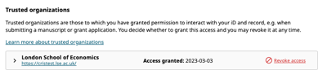

How do I add/remove access to a trusted individual?
For trusted individuals, the trusted parties page is broken down into three sections:
- A list of trusted individuals you’ve given access to.
- A search function to add new trusted individuals.
- A list of users that set you as their trusted individual.

To add new trusted individuals to your account, simply enter the ORCID, email address, or name of the person you wish to grant access to, and then click “Search ORCID for trusted individuals”. ORCID at which point will present a list of users that fit your criteria. Click on “+ Add as trusted individual” to any one of these users.

To revoke access to a trusted individual, the process is much the same as trusted organisations. Simply click on “Revoke access” located to the far right on a trusted individual’s record.

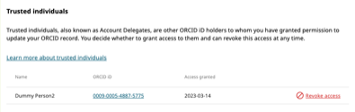

08/23

