structuring the International Tax Regime:
A Proposal

Eduardo Baistrocchi

The international tax regime (ITR) faces an existential challenge in the early 21st century. There are good reasons to argue that the world economy is dealing with a trilemma: Liberal democracy, national determination, and economic globalisation cannot coexist because they are now incompatible. So a central question is how the ITR global governance structure may be adapted to help solve the incompatibility problem and make the ITR more responsive to the needs and values of people worldwide.
This piece outlines a proposal that aims to be the first step in solving the incompatibility problem by setting up a platform for standardisation agreements in international taxation under the United Nations’ control (the platform). The platform aims to achieve institutional integration in the ITR between the global north and the global south.
The legal treatment of standardisation agreements in EU antitrust law inspires the proposal. It has been designed to be compatible with both the Framework Convention for the Promotion of Inclusive and Effective International Tax Cooperation approved by a UN General Assembly resolution in 2023 and the Inclusive Framework on Base Erosion and Profit Shifting established by the OECD and G-20 in 2016.
The platform for standardisation agreements in the ITR would consist of four building blocks: 1) The UN Global Committee on Proposals for Standardisation Agreements (UN Tax Committee), 2) The OECD Centre For Tax Policy and Administration (OECD CTPA), 3) the UN General Assembly, and 4) the UN Global Observatory.
The first three building blocks of the platform would serve the role of agreeing on the international tax standards on an ongoing basis (the Conference of the Parties). The fourth building block, the UN Global Observatory, would, in turn, monitor and offer feedback to the Conference of the Parties on the interpretation and application worldwide of the agreed standards to further improve their effectiveness. Figure 1 below offers a graphical representation of the platform.
Figure 1: The UN Platform for Tax Standardisation Agreements

The platform has four building blocks, each with distinct roles. The UN Tax Standardisation Committee is tasked with creating the first draft of the material international tax standards. The committee is composed of sixteen members, eight representing developed countries (the global north) and the other eight representing developing and emerging countries (the global south). Committee members are selected based on their contribution to the global gross domestic product (global GDP).
The global north would be represented by G7 countries and the European Union (EU). The global south, in turn, would be represented by eight clusters of jurisdictions: the African Union, ASEAN, BRICS, G77, India, Indonesia, Mercosur, and the People’s Republic of China.
The UN Tax Standardisation Committee would have one vote per member, and decisions would be made based on a simple majority. For instance, if a draft proposal for tax standardisation receives nine votes, with eight votes from the global north and one from the global south (or vice versa), it would be presented to the OECD CTPA as the first draft.
The OECD CTPA would then be responsible for producing the second draft of the standardisation proposal, grounded on legal and technical work necessary to implement effective change in the ITR, within the wording of the 2023 UN Secretary General resolution. The second draft will be sent to the UN Tax Standardisation Committee for review. If the committee approves this draft, it will be submitted to the UN General Assembly for consideration. This means that international tax policy will be created by the UN General Assembly, with input from the UN Tax Standardisation Committee.
The proposal for a tax standardisation agreement will be subject to the approval or rejection of the United Nations General Assembly. The decision would be made by a majority vote of the present and voting members, in accordance with Article 18 of the United Nations Charter.
The proposal of the UN Tax Standardisation Committee, if approved by the UN General Assembly, can either become soft or hard law. In case of the former, the relevant standardisation agreement could be added, for example, to the UN and/or the OECD Model as soft laws. On the other hand, the standard could become hard law, like the protocol on the taxation of income derived from the provision of cross-border services in an increasingly digitalised and globalised economy, within the wording of the 2023 General Assembly resolution. If the UN General Assembly rejects the UN Tax Standardisation Committee’s proposal, it will be sent back to the committee for reformulation and a fresh start to the reform proposal process.
Finally, the UN Global Observatory will offer feedback to the Conference of the Parties concerning the interpretation and global implementation of the material tax standard. This feedback will enable the UN Committee to assess the overall impact of the standardisation agreements on the functioning of the ITR and suggest further enhancements.
The platform is compatible with current reforms discussed by the Inclusive Framework on Base Erosion and Profit Shifting established by the OECD and G-20 in 2016. For example, the platform may help reach the critical mass of countries needed to successfully implement Pillar Two and its goal of setting a minimum effective corporate tax of 15%. The platform may also decide to improve Pillar Two by, for example increasing the minimum effective corporate tax rate.
To ground the proposal submitted here, we need to answer four questions: (1) Why should the G7 and the EU represent the Global North with eight votes in the UN Tax Standardisation Committee? (2) Why should the Global South be represented by the eight clusters of jurisdictions listed in the UN Tax Standardisation Committee? (3) Why the UN General Assembly? and (4) Why should EU regulations on standardisation agreements be transplanted to the ITR?
The G-7 is an intergovernmental political forum established in 1976. It comprises Canada, France, Germany, Italy, Japan, the United Kingdom, and the United States. The EU has been a non-enumerated member of the G-7 since 1977. The G-7 and the EU accounted for over 44 per cent of global GDP in 2023.
For almost a century, an increasing number of countries that are now part of the G7 and the EU have been controlling the development of the ITR. Indeed, from 1923 to 2021, the League of Nations and the OECD received 3,419 inputs from various stakeholders on international tax policy preferences. These inputs were submitted at nine significant points in the emergence and evolution of the ITR. Each input represents an observable ITR event that can be considered a proxy for soft power in this area of international law. Input is defined here as a statement made by an endpoint jurisdiction (such as the United Kingdom), an international investor (such as Apple Inc.), a tax hub (such as the Netherlands), or a developing country (such as Brazil) to a relevant supranational institution (such as the League of Nations or the OECD) concerning the discussion leading to a material ITR milestone.
An example of input is an opinion submitted by a country in a meeting led by the relevant supranational institution. When meeting minutes are unavailable, the attendance of each member in each session has been coded as input. Conversely, when the minutes detailing the discussions are available, only participants who state an opinion are coded as inputs (mere attendance is insufficient to be coded as input).
Figure 2 below shows, inter alia, the inputs submitted by G-7 countries, tax hubs, and developing countries in ITR history. The horizontal axis lists nine milestones of ITR history from the 1923 Four Economists’ Report to the 2021 BEPS on Pillar One and Pillar Two. The vertical axis represents the percentage of inputs submitted by the relevant stakeholders to the relevant international institution in each of the nine milestones.
According to Figure 2, the G-7 countries have contributed the most inputs to the relevant institution across all nine milestones. This historical trend indicates that the G-7 nations have been the primary soft power in making the ITR by submitting the highest percentage of inputs to the League of Nations and later to the OECD. The G-7 jurisdictions have controlled the initial drafts for most of the nine reforms that make up the ITR milestones.

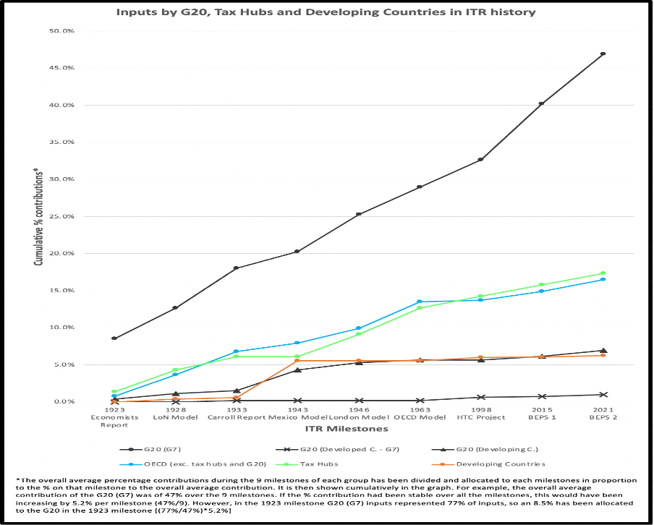
Figure 2: Inputs by G20, Tax Hubs and Developing Countries in the ITR History
This proposal suggests that the G-7 countries and the EU should have eight out of sixteen votes in the UN Tax Standardisation Committee. The allocation of these positions would be based on their contribution to the global GDP as well as their influence in the evolution of the ITR during its first century. The remaining eight spots would be given to eight groups of jurisdictions from the global south, as mentioned earlier, in recognition of their contribution to the global GDP, which was over 44% in 2023.
The UN General Assembly plays a crucial role in evaluating the reform proposals produced by the UN Committee with the feedback from the OECD CTPA. This evaluation process grants all 193 UN jurisdictions a voice and offers moral legitimacy to the platform. .
The strategic interaction between the UN Committee on Standardisation Agreements and the UN General Assembly is similar to the strategic interaction between the Senate and the House of Representatives in a liberal democracy like the US. The Senate aims to represent the interests of jurisdictions regardless of their population size, while the House of Representatives seeks to represent the people themselves.
It is suggested that the principles followed by the EU for standardisation agreements can be used as inspiration for the platform. This includes openness, transparency, and non-discrimination. This transplant is justified as the ITR is a decentralised competitive network market similar to those governed by EU antitrust regulations like two-sided platforms. The EU antitrust regulations could apply to the platform if the platform decides to follow it, as interpreted by the Court of Justice of the EU.
In sum, this note proposes the creation of the UN Platform for Standardisation Agreements in the ITR in order to solve the problem of incompatibility and implement the framework convention recently mandated by the UN General Assembly. The platform’s goal is to empower weaker actors, such as developing countries, by building cross-issue coalitions to increase their bargaining power and influence in international taxation. The concept of standardisation agreements could serve as a good starting point in the search for a new global social contract in this critical area of international law.

2 Dani Rodrik, THE GLOBALIZATION PARADOX: DEMOCRACY AND THE FUTURE OF THE WORLD ECONOMY, Oxford University Press, xviii-xix (2011).
Eduardo Baistrocchi, International Taxation, the G-7, and India: A Proposal (October 30, 2023). Tax Notes International, October 30, 2023, p. 653-660, https://ssrn.com/abstract=4630033
E. Baistrocchi, Global Tax Hubs, Florida Tax Review, Spring 2024, forthcoming, https://ssrn.com/abstract=4544786

