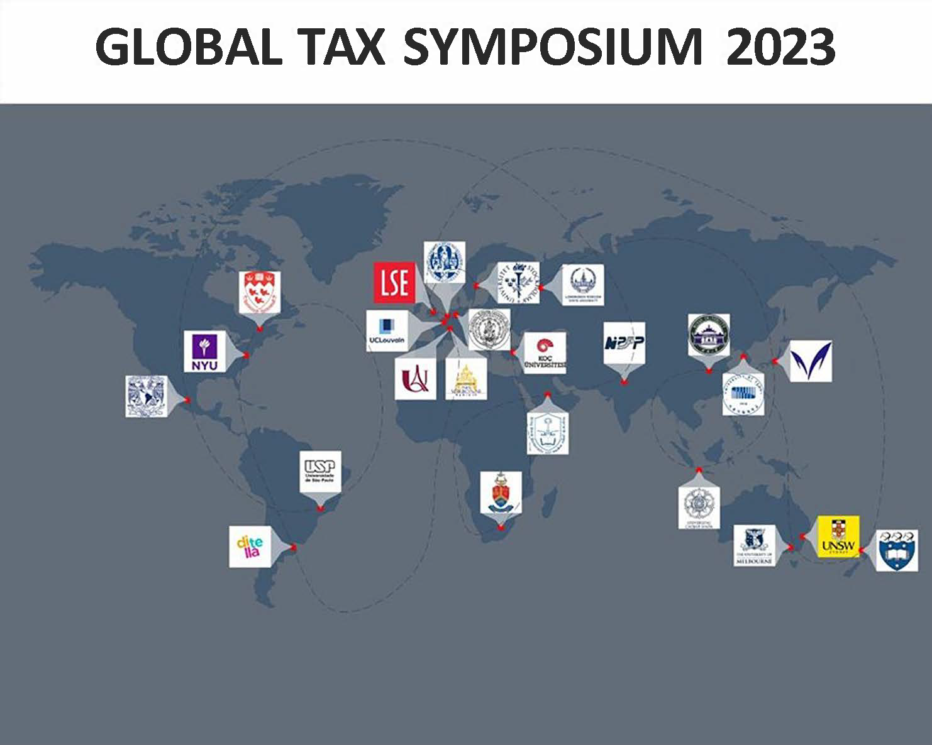
GLOBAL TAX SYMPOSIUM 2023 – Monday, 4 and Tuesday, 5 December 2023 - Hybrid event

Steering Committee
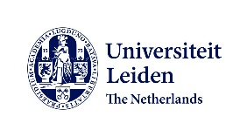

Mission and vision of the Global Tax Symposia

The mission of the Global Tax Symposia (GTS) is to be an interdisciplinary mobile research platform on fundamental issues of international and comparative taxation. It is grounded in the belief that crossing African, American, Asian-Pacific and European perspectives is beneficial to all participants, especially in the current political and economic global context. It aims to offer young researchers and experienced scholars a forum in which to discuss five to six papers every year in different cities on all continents. Each paper is discussed by an interdisciplinary and intercontinental panel whose members are leading tax academics, tax practitioners, tax officials and tax policymakers.

The following institutions from all continents support the initiative: Fundación de Investigaciones Económicas Latinoamericanas (Argentina),
Universidad Torcuato Di Tella (Argentina), University of Melbourne and University of New South Wales (Australia), University of Louvain (Belgium), University of São Paulo (Brazil), McGill University (Canada), Wuhan University (People's Republic of China), Sorbonne Law School (France), University of Münster (Germany), National Institute of Public Finance and Policy (India), Universidad Nacional Autonoma de Mexico(Mexico), Leiden University and ERC funded project GLOBTAXGOV (The Netherlands), University of Auckland(New Zealand), Moscow State University (Russian Federation), King Saud University (Saudi Arabia), University of Pretoria (South Africa), University of Seoul (Korea), Stockholm University (Sweden), London School of Economics (United Kingdom), Meiji University and University of Tokyo (Japan), Universitas Gadja Madha (Indonesia), Koç University(Turkey) and New York University (United States of America).

The First, Second and Third Editions of the Global Tax Symposia were held at the London School of Economics, Louvain University and Leiden University in 2019, 2020 and 2021 respectively. All paper presentations and videos of both symposia are available here: 2019, 2020 and 2021.
The 2022 Global Tax Symposium was organized by Assistant Prof. Suranjali Tandon (National Institute of Public Finance and Policy India), Prof. Irma Mosquera Valderrama (University of Leiden – GLOBTAXGOV), Prof. Edoardo Traversa (UCLouvain), Prof. Miranda Stewart (University of Melbourne), Prof. Joachim Englisch (University of Muenster) and Assoc.-Prof. Eduardo Baistrocchi (London School of Economics).
The 2023 Global Tax Symposium is organized by Prof. Luis Eduardo Schoueri (University of São Paulo) and Prof. Isabel Calich (Instituto Brasileiro de Direito Tributário – IBDT) and it will be held at São Paulo Commercial Association, (Brazil) in a hybrid format, in which students from University of São Paulo and the Brazilian participants will be present at the event.

The Scope: Global Awareness

To assess worldwide tax developments in the past ten years and the future, the term 'global awareness' is paramount. The number and diversity of stakeholders involved in international tax discussions has expanded and this, in turn, has enabled the arena to include new perspectives on taxation. The field has also witnessed major international reactions towards tax controversies that used to be dealt with in national and private meetings as well as the courts. Most recently, concerns have grown about the impact of tax measures around the world during and after the COVID-19 pandemic. Endeavours have been made towards expanding international tax legislation, to move forward with the introduction of tax standards to align national tax systems with each other and to develop new approaches to international tax, continuing a trajectory for those who have been engaged with the international tax programmes of the Organisation for Economic Cooperation and Development (OECD) and the United Nations (UN). At the same time, there are increasing concerns regarding processes of transparency, legitimacy and global governance in international taxation. Governments seem to be open to discuss and adopt new commitments to tax matters, despite showing some resistance to providing complete reformulations of tax policy.

The 2023 Global Tax Symposium will address topics on New Frontiers of International Taxation including principled, theoretical or pragmatic issues connected to tax and development. The select themes covered by this symposium are:
- Pillar II – Challenges of its implementation in developed and developing countries.
- Wealth Taxation- recent experiences.
- Offshore finance and taxation.
- Tax reform in Brazil – Income tax and Consumption tax.
- Transfer pricing – current issues.
- Multilateralism.

The sessions in the 2023 Global Tax Symposium will combine academic papers and panel discussions including the participation of government officials from ministries of finance and tax agencies, academics, tax practitioners, and researchers in different disciplines on taxation from all continents.
Information and registration:
Link to registration: (https://us06web.zoom.us/m
eeting/register/tZYodeytpzgoH914mov9WLLgW5pG3BMy78x1)
Scientific contact: Prof. Luís Eduardo Schoueri (schoueri@lacazmartins.com.br) and Isabel Calich (belcalich@gmail.com)

 |  | EST time  (-2h) | SP time  (0hs)) | CET time  (+4hs) | IST (India Time) (+8:30min) | Melbourne time  (+14hs) | Presenters
 | Monday 4, December
Panel Discussion: Tax reform in BRAZIL – Consumption Taxation |  |  | Chair: Joachim Englisch, Professor of Tax Law, University of Münster
Panel discussion |  | 06:00 | 08:00 | 12:00 | 16:30 | 22:00 | - Melina Rocha, International Consultant on VAT/GST. Course Director at York University. PhD Sorbonne Nouvelle.  - Bernard Appy, Secretary of Tax Reform  - Roberto Quiroga, Professor of Law at USP  - Ian Roxan, Associate Professor of Law, LSE  - Karoline Spies, Professor at WU Vienna University of Economics and Business, Institute for Austrian and International Tax Law.
Q&A |  | 07:20 | 09:20 | 13:20 | 17:50 | 23:20
Break |  | 07:25 | 09:25 | 13:25 | 17:55 | 23:25
Paper 1 |  |  | Chair: Prof. Luis Eduardo Schoueri, Professor of Tax Law, University of São Paulo - USP
Main presentation |  | 07:30 | 09:30 | 13:30 | 18:00 | 23:30 | GLoBE: The Potential Costs of Cooperation  Tsilly Dagan, Professor of Tax Law, Oxford University
Discussion |  | 07:50 | 09:50 | 13:50 | 18:20 | 23:50 | Discussants  - Irma Mosquera Valderrama, Professor of Tax Law, Leiden University  - Natalia Quiñones – International tax expert, Vice President of IFA
Q&A |  | 08:20 | 10:20 | 14:20 | 18:50 | 24:20
Break |  | 08:25 | 10:25 | 14:25 | 18:55 | 24:25
Paper 2 |  |  | Chair: Isabel Calich, Associate Professor of Law, Instituto Brasileiro de Direito Tributário - IBDT
Main presentation |  | 08:30 | 10:30 | 14:30 | 19:00 | 24:30 | The single top-up tax principle: Justification, content and functions upon the design of QDMTTS  Ricardo André Galendi Júnior, Professor of Tax Law, IBDT
Discussion |  | 08:50 | 10:50 | 14:50 | 19:20 | 24:50 | Discussants  - Joachim Englisch, Professor of Public Law and Tax Law, University of Muenster  - Werner Haslehner – Professor of Law, University of Luxembourg
Q&A |  | 09:20 | 11:20 | 15:20 | 19:50 | 01:20
Break |  | 09:25 | 11:25 | 15:25 | 19:55 | 01:25
Paper 3 |  |  | Chair: Eduardo Baistrocchi, Associate Professor of Law, London School of Economics and Political Science
Main presentation |  | 09:30 | 11:30 | 15:30 | 20:00 | 01:30 | A Wealth Tax For the UK Final Report  Andy Summers, Associate Professor of Law, LSE
Discussion |  | 09:50 | 11:50 | 15:50 | 20:20 | 01:50 | Discussants  - Eric Zolt, Michael H. Schill Distinguished Professor of Law, UCL  - Juan Velasco, partner at Baker McKenzie Colombia.
Q&A |  | 10:20 | 12:20 | 16:20 | 20:50 | 02:20
Break |  | 10:25 | 12:25 | 16:25 | 20:55 | 02:25
Paper 4 |  |  | Chair: Irma Mosquera Valderrama, Professor of Tax Law, Leiden University
Presentation |  | 10:30 | 12:30 | 16:30 | 21:00 | 02:30 | Taxing the mobile  Suranjali Tandon, Assistant Professor, National Institute of Public Finance and Policy.
 |  | 10:50 | 12:50 | 16:50 | 21:20 | 02:50 | Discussants  - Sergio Andre Rocha, Professor of Law, UERJ  - Joanna Wheeler, Senior principal research associate at IBFD
Q&A |  | 11:20 | 13:20 | 17:20 | 21:50 | 03:20
Symposium Closes |  | 11:30 | 13:30 | 17:30 | 22:00 | 03:30
 | Tuesday 5, December
Paper 1 |  |  | Chair: Craig Elliffe, Professor of Law, University of Auckland
Main presentation |  | 06:00 | 08:00 | 12:00 | 16:30 | 22:00 | Paper 1: The (Not So) Inclusive Framework and the Multilateral Instrument  Yariv Brauner, Hugh Culverhouse Eminent Scholar Chair in Taxation & Professor of Law, University of Florida
Discussion |  | 06:20 | 08:20 | 12:20 | 16:50 | 22:20 | Discussants  - Diane Ring, Professor of Law and the Dr. Thomas F. Carney Distinguished Scholar, Boston College.  - Lisellote Kana, Professor at WU Vienna University of Economics and Business, Institute for Austrian and International Tax Law.
Q&A |  | 06:50 | 08:50 | 12:50 | 17:20 | 22:50
Break |  | 06:55 | 08:55 | 12:55 | 17:25 | 22:55
Book Discussion |  |  | Chair: Suranjali Tandon, Assistant Professor, National Institute of Public Finance and Policy
 |  | 07:00 | 09:00 | 13:00 | 17:30 | 23:00 | Offshore Finance and State Power  Andrea Binder, Freigeist Fellow and Research Group Leader at the Otto Suhr Institute of Political Science , Freie Universität Berlin.
Discussion |  | 07:20 | 09:20 | 13:20 | 17:50 | 23:20 | Discussants  - Sol Picciotto, Emeritus Professor, Lancaster University  - Isabel Calich, Associate Professor of Tax Law, IBDT
Q&A |  | 07:50 | 09:50 | 13:50 | 18:20 | 23:50
Break |  | 07:55 | 09:55 | 13:55 | 18:25 | 23:55
Paper 2 |  |  | Chair: Luis Flavio Neto, Coordinator and Professor of Tax Law, Instituto Brasileiro de Direito Tributário - IBDT
Main presentation |  | 08:00 | 10:00 | 14:00 | 18:30 | 24:00 | Substance in Transfer Pricing in a Post-BEPS World and Beyond…  Raffaele Petruzzi, Managing Director of the WU Transfer Pricing Center; and Argyro Myzithra, Assistant Manager, Business Tax & Transfer Pricing at Deloitte.
Discussion |  | 08:20 | 10:20 | 14:20 | 18:50 | 24:20 | Discussants  - Jerome Monsenego, Professor of International Tax Law, Stockholm University  - Claudia Pimentel – Secretary of Taxation and Litigation of the Brazilian Tax Revenue  - Clara Gomes Moreira – Associate Professor of Tax Law, IBDT
Q&A |  | 08:50 | 10:50 | 14:50 | 19:20 | 24:50
Break |  | 08:55 | 10:55 | 14:55 | 19:25 | 24:55
Paper 3 |  |  | Chair Paper 4: Jerome Monsenego, Professor of International Tax Law, Stockholm University
Main presentation |  | 09:00 | 11:00 | 15:00 | 19:30 | 01:00 | A Theory of Global Tax Hubs–  Eduardo Baistrocchi, Associate Professor of Law, LSE
Discussion |  | 09:20 | 11:20 | 15:20 | 19:50 | 01:20 | Discussants  - Thomas Rixen, Professor of International and Comparative Political Economy, Freie Universität Berlin  - Edoardo Traversa, Professor of Law, Faculty of Law and Criminology and Institute of European Studies (UCLouvain)
Q&A |  | 09:50 | 11:50 | 15:50 | 20:20 | 01:50
Break |  | 09:55 | 11:55 | 15:55 | 20:25 | 01:55
Panel Discussion: Tax Reform in Brazil – Income Taxation |  |  | Chair Panel discussion: João Dácio Rolim, Professor of Tax Law, Instituto Brasileiro de Direito Tributário – IBDT
 |  | 10:00 | 12:00 | 16:00 | 20:30 | 02:00 | Discussants  - Vanessa Canado, Professor of Law, Insper (SP)  - Daniel Loria, Director of Extraordinary Secretary of Tax Reform in Brazil.  - Luís Eduardo Schoueri, Professor of Law, USP  - Yariv Brauner, Hugh Culverhouse Eminent Scholar Chair in Taxation & Professor of Law, University of Florida  - Gustavo Vettori, Professor of Tax Law of the School of Economics, Business and Accounting of São Paulo – FEA
Q&A |  | 11:20 | 13:20 | 17:20 | 21:50 | 03:20
Symposium Closes |  | 11:30 | 13:30 | 17:30 | 22:00 | 03:30

