The 2027 Global Tax Symposium, call for papers

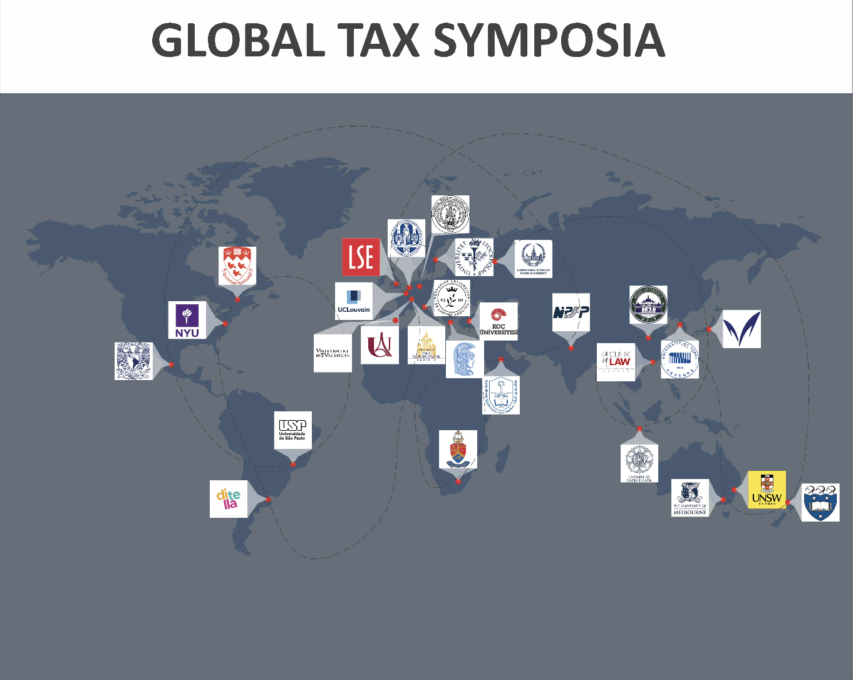

The Global Tax Symposia (GTS) are an interdisciplinary research platform on fundamental issues of international and comparative taxation. They bring together researchers and scholars from Africa, America, Asia, Asia-Pacific, and Europe to explore contemporary tax issues shaped by global political, institutional, and economic developments. The GTS offers two forums each year for researchers and scholars to discuss cutting-edge issues in tax law and policy. The PhD Global Tax Symposium targets early-career researchers, while the Global Tax Symposium focuses on papers written by more experienced scholars.
The following institutions have supported the GTS:
Africa: University of Pretoria (South Africa); Americas: Universidad Torcuato Di Tella (Argentina), University of São Paulo (Brazil), McGill University (Canada), New York University (United States of America); Asia: Wuhan University (People’s Republic of China), Meiji University (Japan), National Institute of Public Finance and Policy (India), Universitas Gadja Madha (Indonesia), Moscow State University (Russian Federation), King Saud University (Kingdom of Saudi Arabia), University of Seoul (South Korea); Asia-Pacific: the University of Melbourne (Australia), the University of New South Wales (Australia), University of Auckland (New Zealand); Europe: University of Louvain (Belgium), Sorbonne Law School (France), University of Münster (Germany), Leiden University and ERC funded project GLOBTAXGOV (the Netherlands), Stockholm University (Sweden), Koç University (Turkey), Valencia University (Spain), London School of Economics (United Kingdom) and the University of Ferrara (Italy).

The 2027 Global Tax Symposium

The 2027 Global Tax Symposium will be organised and hosted by the New Zealand Centre for Taxation, the University of Auckland (New Zealand). The event will last two days and be organised as a hybrid conference, with participation either on-site or online.
Date: 9 and 10 December 2027.
The Symposium’s Theme: “Taxes and Space”.
Taxation is, at its core, a spatial phenomenon. We call for papers that make an intellectual contribution to understanding taxation as a spatial phenomenon along any of the following dimensions:
- inner space: the allocation of taxing rights between central and regional governments, and the tax treatment of economic activity that crosses internal administrative boundaries;
- outer space: the commercialisation of the cosmos, as the ultimate test for tax principles developed for a terrestrial world;
- physical space: how the link to physical space has shaped tax rules and how tax rules affect the use of the physical space;
- regulatory and policy space: how domestic tax rules and international tax agreements create constraints and opportunities for states, multinational enterprises and wealthy individuals.
Against this backdrop, the 2027 Global Tax Symposium invites submissions of scholarly papers that address the aforementioned questions, challenges, or other contemporary taxation issues, with an international or comparative perspective. The symposium welcomes both theoretical and empirical research contributions.
The papers to be presented at the symposium will be selected by the GTS steering group.
Each selected paper will be commented on by panel members from academia, professional institutes, and government agencies with diverse interdisciplinary and regional backgrounds. If you are interested in presenting at the 2027 Global Tax Symposium, please submit the draft paper in Word or Adobe PDF format to both c.elliffe@auckland.ac.nz and victoria.plekhanova@auckland.ac.nz .
The submission deadline is 1 February 2027. Authors of accepted papers will be notified by 1 April 2027. For past Global Tax Symposium sessions, please see the link below:
https://www.lse.ac.uk/law/research/taxation-global-tax-symposium

