LSE IN THE HAGUE
Proposed Dates:
24-26 April 2023 OR 18-21 June 2023
(to be determined)

Application form
deadline: Friday 3 March 2023

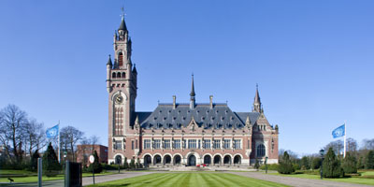

Please fill in your answers electronically.

A. Personal History

1. Last name:
First and middle names:

2. Nationality(ies):

3. Gender:

4. Postal address:

5. Telephone:

6. Email:

7. Emergency Contact details:

8. Please Attach Good quality Professional Photograph of Yourself (for inclusion in Trip Manual).

9. Please Include a Brief Biography (For Inclusion in Trip Manual).

B. Available Trip Dates
- Only one trip will take place – please select both if possible for you.
- If you have a preference for a particular date, but can do both, please circle ‘both’ and explain your preference

24-26 April 2023 18-21 June 2023 Both

C. LSE LLM: Courses and Marks

Course | Course Teacher(s) | Formative Essay Marks

C. LLM Dissertation Topic? (If Topic not known, please indicate the area/s of law and arguments you are considering for your dissertation)

D. Please Explain your Interest in Joining the Trip to the Hague, including how it might tie into your future career aspirations, if relevant. (max half page)

E. Describe How You Would Most Like to Spend Three Days in the Hague, including reference to institutions you would most like to visit, judges or other institution employees you would like to meet, cases you would like to observe etc. (max half page)

F. University Education

Name, City and Country | Attended From/To |  | Overall Degree Classficiation and Academic Distinctions Obtained | Main Course of Study
Name, City and Country | Month/Year | Month/Year |  | Main Course of Study

G. Relevant Experience

Please list any relevant work Experience, internships, apprenticeships, pro-bono work and Leadership Positions below (if any)

A. | Name and address of the Organization
 | Exact Title of your Post
 | Duration
Duties and Key Achievements
(max 200 words)

B. | Name and address of the Organization
 | Exact Title of your Post
 | Duration
Duties and Key Achievements
(max 200 words)

H. Additional Information
(max 300 words)
- Please explain if you would be unable to join the trip in the absence of additional financial assistance (ie. beyond the contribution of £200 to travel costs provided to all students)
- Please state any other relevant facts, including any awards, prizes or distinctions earned; conferences and seminars attended and competitions participated in.
- If you have any contacts with which we might speak as a group when in The Hague this would also be interesting to know!

By signing below, I confirm that the information in this form is accurate and agree that it may be used by LSE, particularly for the purpose of materials produced for the trip to The Hague.

Electronic Signature: __________________________ Date: ____________________

