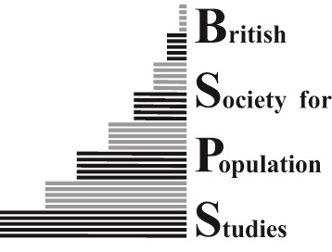
British Society for Population Studies: Proposal for meeting funding

BSPS is keen to support events that promote discussion of topics within the society’s remit, ‘to further the scientific study of biological, economic, historical, medical, social and other disciplines connected with human populations and to contribute to the public awareness of them’.

The most common form of BSPS events are day meetings, but the society will also fund longer or shorter events and joint events if they fit within the society’s remit. BSPS-funded meetings must be open to all BSPS members (normally free of charge) and advertised to the BSPS membership and beyond. The funding amount BSPS will provide for a meeting varies, averaging about £750, with the usual maximum being £1500. Events must acknowledge funding from BSPS and include the BSPS logo on printed and online materials (websites, workshop programmes, etc.). Individuals requesting funding will be expected to be current BSPS members in good standing.

Proposals for BSPS events or joint events should be made by completing the form below, to be considered by BSPS Council which usually meets in the early January, April and November, although they may also be circulated by email.

Please contact the BSPS Secretariat (pic@lse.ac.uk) with any queries about the information requested below. If your proposal is at the early stages, the Secretariat may be able to put you in contact with other BSPS members who can help to think through and organise the event.

Funding Request Form

Your name, affiliation and contact details (the organiser; add others if there is an organising team):

Are you a member of BSPS?:

Draft title of proposed event:

Description of event (50-100 words, to include content and aims, which might be used in advertising the event):

Audience expected (largest likely number, and whether likely to be most attractive to particular sectors):

Date, start and finishing time (approximate if not decided):

Venue (BSPS may be able to book rooms without cost at the London School of Economics, but other venues may be more appropriate):

Suggested speakers (please indicate whether these have already been approached):

Draft budget: A draft budget MUST be provided before funding can be considered. Please attach a fully itemised budget detailing the estimated costs of the proposed event. The full budget should include, but is not limited to, speakers’ expenses (travel, plus accommodation if required), refreshments for speakers and the audience (lunch and coffee/tea), and cost of venue and AV. Please indicate what costs the BSPS is being asked to fund and their share of the total costs of the event. Applications will be judged in part based on their economy, and the society expects organisers to keep costs to a reasonable standard.

If a joint meeting with another organisation, please give its name and the intended contributions of that organisation (e.g. funding, programme, advertising, liaison with speakers and venue, booking arrangements):

Return the completed proposal to the BSPS Secretariat – pic@lse.ac.uk.

