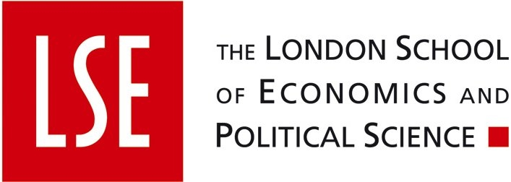


Grantham Research Institute  on Climate Change and the Environment | Grantham Institute  for Climate Change

CARBON MARKETS
- One Day Workshop - Tuesday May 5, 2009
AGENDA:
09.00-9:30 REGISTRATION & WELCOME COFFEE
9:30-9:45 OPENING REMARKS
Simon Dietz, Deputy Director, Grantham Research Institute on Climate Change and the Environment, LSE
Brian Hoskins, Director, Grantham Institute for Climate Change, Imperial College London
9:45-10.15 KEYNOTE ADDRESS
“The European Carbon Market in Action: Lessons from the First Trading Period”
Christian De Perthuis, Director at Mission Climat Caisse des Dépôts and Professor at the University Paris Dauphine
10.15-10.45 POLICY BRIEFING
“Marginal Abatement Costs and Implications for Carbon Finance”
Marcel Brinkman, McKinsey & Company
10:45-11:15 COFFEE BREAK
11.15-12.45 PLENARY SESSION
“Carbon finance and the economic crisis: where are we?”
Panel: - Henry Derwent, President and CEO of the International Emissions Trading Association (IETA)
- Peter Höppe, Head of Geo Risks Research, Munich Re
- Hans-Bernd Menzel, CEO of the European Energy Exchange (EEX)
- Guy Turner, Director at New Carbon Finance
- Willem Buiter, LSE
Chair: Sam Fankhauser, Principal Research Fellow, Grantham Research Institute on Climate Change and the Environment, LSE
12.45-14.15 LUNCH
Shaw Library, Old Building, LSE
14.15-17.00 | PARALLEL SESSION 1  Room G108, 20 Kingsway – Entrance in Portugal Street | PARALLEL SESSION 2  Room U8, Tower 1
 | “Perspectives on Carbon Markets and a Post-Kyoto Climate Treaty”  What are the governance effects of emerging carbon markets and what role will they play in a post-Kyoto treaty ? How will the current financial and economics crisis impact the outcomes ? The session will feature academic papers on these timely questions. | “Recent Developments in Carbon Finance”  What is the state of knowledge on financial econometrics techniques applied to emissions markets? How do carbon allowances relate to energy and commodity markets? This session will present academic papers of the emerging literature on carbon finance.
14.15-15.45  Presentations: | 1) Tora Skodvin, CICERO | 1) Luca Taschini, Swiss Finance Institute
 | 2) Markus Lederer, University of Potsdam | 2) Joerdis Klar, University of Bonn
 | 3) Chukwumerije Okereke, Oxford University | 3) Benoit Sevi, University of Angers
15.45-16.00 | COFFEE BREAK | COFFEE BREAK
16.00-17.00  Discussion: | Robert Falkner, LSE | Derek Bunn, London Business School
Chair: | Christopher Wright, LSE | Julien Chevallier, Imperial College London

17.00: WORKSHOP END
17.00-19.30: RECEPTION Senior Dining Room, Old Building, LSE


The workshop is supported by

