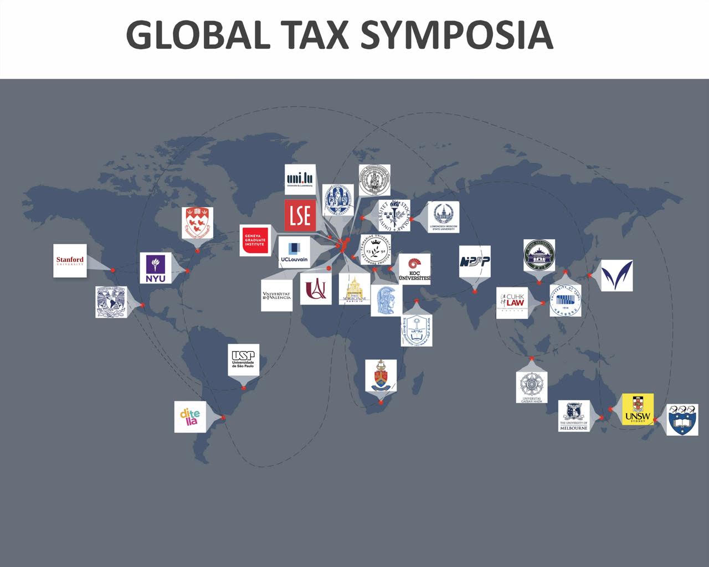
PROGRAM: 2026 PHD GLOBAL TAX SYMPOSIUM
HOST: UNIVERSITY OF PRETORIA, SOUTH AFRICA
DATE: 28 – 29 SEPTEMBER 2026
VENUE: CONFERENCE CENTRE (ROOM 100)
NOTE:
- The regional time is for general guidance, participants need to cross check the time in their specific countries
- Online link for 28 September – accessible an hour before commencing time for testing: https://eu.bbcollab.com/guest/5fcfda9ab492459b8ae73e89013d387f
- Online link for 29 September - accessible an hour before commencing time for testing: https://eu.bbcollab.com/guest/733cffebefa241869c72959b5d8d99ad
- For in-person participants, see the map to the venue below
- For on-line participates, see time zone for some countries below

DAY 1: 28 SEPTEMBER 2026 https://eu.bbcollab.com/guest/5fcfda9ab492459b8ae73e89013d387f
Commencing time: 8:15am – Opening Remarks
Asia-Oceania (early slot)
Presenter  (University) | Title | Discussant  (University) | Moderator  (University) | South African Time | Central European Time | America  Eastern Time | Asia- Oceania  Time
- Dr JakubJankowski (University of Poland, online) | The role of the substantive business activity test in the beneficial owner and abuse-of-law concepts | Prof Craig Elliffe (University of Auckland, New Zealand) | Prof Annet Oguttu  (University of Pretoria) | 8:30 am – 9:30 am | 8:30 am -9:30 am | 2:30 am – 3:30 am | 12:00 pm – 1:00 pm
- Prateek Mishra (KIIT School of Law, Odisha, India, online) | Faceless Adjudication to Resolve Cross Border Tax Disputes: A Comparative Study in Consonance with BEPS Reforms | Prof Yan Xu (University of New South Wales Business School, Australia) | Prof Stephanus van Zyl (University of Pretoria | 9:30 am – 10:30 am | 9:30 am – 10:30am | 3:30 am-4:30 am | 1:00pm – 2:00pm
Break: 10:30 -11:00
Europe-Africa (central slot)
- Chacha Mairo Wansaku (University of Potsdam, Germany - online) | Implications of the EU Carbon Border Adjustment Mechanism on the Tanzania Legal  and Institutional Framework for Carbon Pricing: A Case for East and Southern African  Countries | Prof Irma Mosquera Valderrama (Leiden University, The Netherlands) | Prof Liezel Tredoux (University of South Africa) | 11:00 am – 12:00 pm | 11:00 am – 12:00 pm | 5:00 am – 6:00 am | 2:30 pm- 3:30 pm
- Khodane Sengwane (University of Pretoria, South Africa, in-person | Addressing the challenges of jurisdiction to tax corporate income in the digital  economy: A South African perspective | Prof Daniel Gutmann  (University of Paris, France) | Dr Bernd Schlenther  (University of Pretoria) | 12:00 pm –  13:00 pm | 11:00 am –  12:00 pm | 6:00am-7:00am | 2:00 pm-3:00 pm
Lunch time: 1:00 – 2:00 pm
Europe (last slot)
5) Linda Sydänmaanlakka (University of Helsinki, Finland, online) | History of Hegemony: Global Tax Governance and the OECD | Prof Marco Greggi (University of Ferrara, Italy) | Prof Miranda Stewart  (New York University, USA) | 2:00 pm – 3:00pm | 2:00 pm – 3:00pm | 8:00 am – 9:00 am | 3:00 pm – 4:00 pm
DAY 2: 29 SEPTEMBER 2026 https://eu.bbcollab.com/guest/733cffebefa241869c72959b5d8d99ad

Commencing time: 8:30am
Asia-Oceania (early slot)
Presenter  (University) | Title | Discussant  (University) | Moderator  (University) | South African Standard Time | Central European Time (CET) | America  (Eastern time) | Asia-Oceania
6) Ariuka Bayarsaikhan, (Curtin University, Australia - in person) | Home-Office Permanent Establishments: Should Australia Adopt the OECD 2025 Approach? | Prof Noam Noked (Chinese University of Hong Kong) | Dr Ruddy Kabwe (University of Pretoria) | 8:30 am – 9:30 am | 8:30 am – 9:30 am | 2:30 am- 3:30 am | 2:30 pm-3:30 pm
7) Balete A Yemata, (University of Melbourne -online) | Income Tax Exemptions for Civil Society Organisations in Ethiopia: Lessons from South Africa and Kenya. | Prof Suranjali Tandon  (National Institute of Public Finance and Policy, New Delhi, India) | Prof Shaun Parsons  (University of Cape Town, South Africa) | 9:30am – 10:30 pm | 9:30am – 10:30 am | 3:30 am  4:30 am | 1:00pm- 2:00pm
Break: 10:30 -11:00
Europe-Africa (central slot)
8) Paula Granell, (University of Valencia, France - online) | Reducing Complexity in Transfer Pricing: Policy Options for a More Inclusive  International Tax System | Prof Jérôme Monsenego  (Stockholm University, Sweden) | Dr Carolina Meyer (University of Pretoria, South Africa) | 11:00 am –  12:00 pm | 11:00 am –  12:00 pm | 5:00 am – 6:00 am | 12:00 pm -13:00 pm
9) Remke Beerens (Vrije Universiteit Brusse, Belgium -online) | Mobile individuals, tax sovereignty and the fair allocation of taxing rights in a digitalised world | Prof Edoardo Traversa  (Université Catholique de Louvain, Belgium) | Dr Mpumi Monageng, (University of Pretoria, South Africa) | 12:00pm – 1:00 pm | 12:00pm – 1:00 pm | 6:00 am- 7:00 am | 1:00 pm – 2:00 pm
Lunch time: 1:00 – 2:00 pm
America (last slot)
10) Frank Kalizinje, (University of Pretoria, South Africa - in person) | Can Fiscal Decentralisation break Malawi’s Poverty Paradox? Evidence from  Household Panel and District Fiscal Data | Prof Miranda Stewart  (New York University, USA) | Dr Lindelwa Ngwenya (University of Pretoria) | 2:00 pm – 3:00pm | 2:00 pm – 3:00pm | 8:00 am – 9:00 am | 3:00 pm-  4:00 pm

MAP: USE THE LYNWOOD ENTRANCE TO ACCESS THE UP HATFIELD CAMPUS
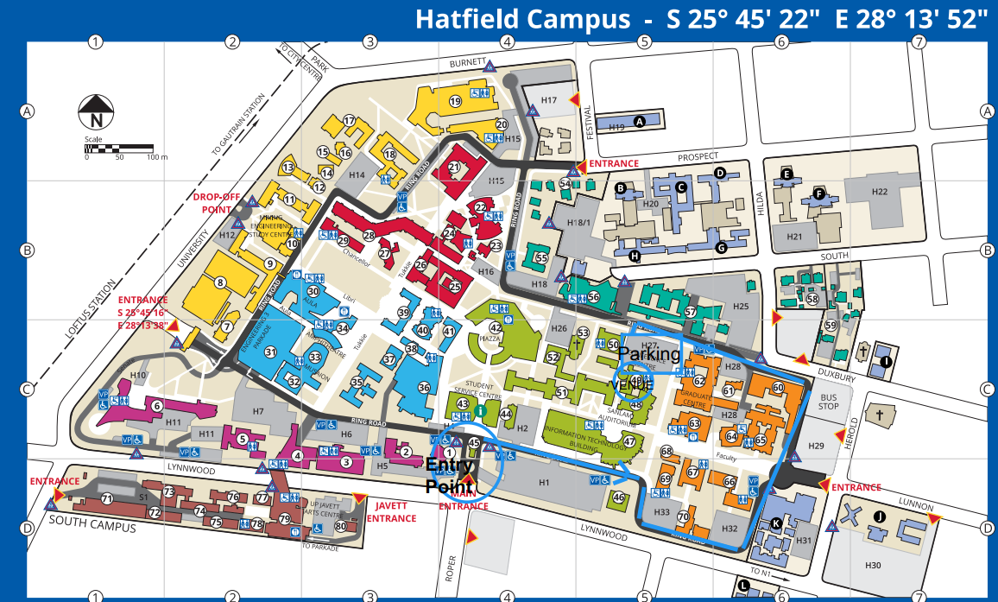
TIME ZONES
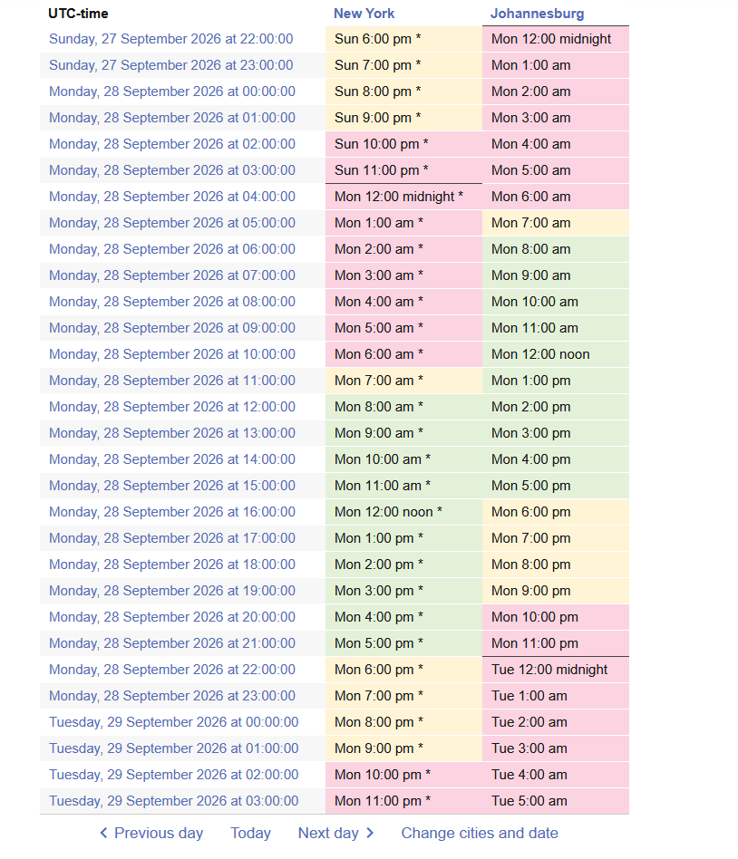

UNIVERSITIES AND INSTITUTIONS REPRESENTED AT THE 2026 PHD GLOBAL TAX SYSMPOSUM
1 | University of Poland | 14 | Curtin University, Australia | 27 | University of Auckland, New Zealand
2 | KIIT School of Law, Odisha, India | 15 | University of Melbourne, Australia | 28 | University of New South Wales, Australia
3 | University of Potsdam, Germany | 16 | University of Valencia, Spain | 29 | Leiden University, The Netherlands
4 | University of Pretoria, South Africa | 17 | Vrije Universiteit Brusse, Belgium | 30 | University of Paris, Italy
5 | University of Helsinki, Finland | 18 | London School of Economics, UK | 30 | University of Ferrara, Italy
6 | Chinese University of Hong Kong | 19 | National Institute of Public Finance and Policy, New Delhi, India | 31 | Stockholm University, Sweden
7 | University of Louvain, Belgium | 20 | University of South Africa | 32 | New York University, USA
8 | University of Cape Town, South Africa | 21 | University of Münster, Germany | 33 | McGill University, Canada
9 | Latin American Economic Research Foundation, Argentina | 22 | National Autonomous University of Mexico | 34 | University of Seoul, South Korea
10 | Meiji University, Japan | 23 | Gadaj Madah University, Indonesia | 35 | Wuhan University, China
11 | King Saud University, Saudi Arabia | 24 | Sorbonne University, France | 36 | Moscow State University, Russia
12 | Koç University, Turkey | 25 | Ferrara University, Italy | 37 | Torcuato Di Tella University, Argentina
13 | University of São Paulo, Brazil | 26 | Geneva, Graduate Institute, Switzerland | 38 | Stanford University, USA

