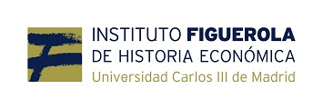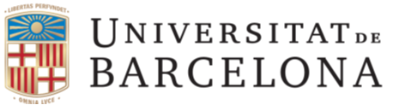

Dear PhD candidate,

After a three successful meetings at LSE in London (2013), Geneva (2014) and Barcelona (2015) we are organizing the fourth round of the Workshop “the New Economic Historians of Latin America” in Madrid in January 2017 in collaboration with the Instituto Figuerola of the Universidad Carlos III de Madrid and the kind support of Fundacion Areces (Madrid) and the Spanish network ‘Globalization, Growth and Inequality’ (ECO2015-71534 REDT).
The workshop brings together PhD students working on any field, period or region of Latin America’s Economic History to present their research among peers and to discuss it with a group of economic historians and scholars interested in the economic history and development of the region more broadly.
We are now looking for PhD students working in the final stage of their doctorate who would benefit the most from a friendly and constructive discussion of their research in a one day workshop. This time the gathering will take place on the 20th January at the Fundacion Areces in Madrid and organizers will partly cover travel and lodging expenses.
Interested participants should submit: 1) a title and an abstract of the paper (500 words) together with 2) a short CV and 3) a paragraph placing the paper in the expected final structure of the dissertation. Submissions should be sent to Alejandra Irigoin (m.a.irigoin@lse.ac.uk) by July 20th 2016.
The deadline for the final papers is November 15th 2016 for pre-circulation among discussants and other attendees.
Best wishes,

Convenors
Alfonso Herranz (Universitat de Barcelona) alfonso.herranz@ub.edu
Alejandra Irigoin (LSE) m.a.irigoin@lse.ac.uk
Local host Antonio Tena (Antonio.tena@uc3m.es)

